Contents

Analysis Stage 2

Introduction 2

Computational Thinking 2

Thinking Abstractly 3

Thinking Ahead 3

Thinking Procedurally 3

Thinking Logically 5

Thinking Concurrently 6

Stakeholders 6

Interview 1 7

Interview 2 8

Interview 3 9

Existing Solutions 10

Essential Features 20

Limitations 21

Software and Hardware Requirements 24

Success Criteria 25

Design Stage 29

Decomposition 30

Structure 31

Algorithms / potential solns 32

Variables, Data structures, Classes 33

Test Data 34

Extra 35

Implementation Stage 36

Stage 1 37

Stage 2 38

Stage 3 39

Testing Stage 40

# Analysis Stage

## Introduction

In my project I plan to create a platformer game that involves a lot of problem solving and logical reasoning, similar to some well-known games including: ‘Trap Adventure 2’, the ‘Super Mario’ series, and ‘Dead Cells’. All three of these games are kinds of platformer games. In ‘Trap Adventure 2’ and games from the ‘Super Mario’ series, the gameplay is mainly focused on parkour and evasion of obstacles to win. Both of these involve a life system where if the player is defeated or fails too many times, their progress is reset. In ‘Super Mario’ games and ‘Dead Cells’, completing certain objectives such as beating levels, or defeating enemies rewards you with score points or some form of reward or currency that can be used later on to benefit the player. In these games, completing a level brings you to the next, more difficult level, once all levels are completed the game ends and the player may replay if they wish to.

## Computational Thinking

The problem is solvable using computational methods because it is a game. Since the game is a platformer type of game, it will require inputs (to recognise what the player is doing so it can be drawn onto the screen or responses by the game can be made, especially movement and actions). When a player plays the game, the game also has to be interactive with the player since otherwise, the player is just making inputs and getting nothing out of it, which wouldn’t really mean they are playing a game, this means the game also has to output things to the player and runs calculations to tell what the player is doing. These require algorithms to do and therefore allows the problem to be solved via computational methods. The fact that the game has a form of repetition to it (due to levels, timers, scoreboards etc) also means that algorithms need to be used repeatedly to solve this problem.

### Thinking Abstractly

Thinking abstractly provides me with limits and boundaries to what I need to add to the game, it ensures that I only implement what is necessary and avoid adding irrelevant details or features that also may cause problems.

Some abstractions I have are for example:

* Implement game in 2 dimensions, as I am using pygame to build my game, which is better suited for a 2D style.
* Add basic and distinguishable sound effect for base features such as when collecting collectible, jumping.
* Keeping the game single player rather than multiplayer as it would complicate how gameplay works (i.e will the players play on different devices? If sharing the same advice how would I get them to play on the same screen since what if a character moves to one side and the other one is on the other side, which way does the screen shift towards? (world scroll))

### Thinking Ahead

This way of thinking allows me to decide and plan ahead what I will do. This is important since if I do everything concurrently, there wouldn’t have been much time to properly think out what the best ways of accomplishing my goals are. It provides proper organisation so that when I do get to designing, and creating code, everything will be well organised so that I know exactly what to do, when, and how. This simply makes things easier for me since if I have to both think and do at the same time, I am more likely to make errors. Some things I plan on doing or using are:

* Using python; pygame to write my game as it is good for producing these type of retro games, especially since mine is pretty much all 2 dimensional and pygame is good for drawing 2 dimensional things.
* I know what base controls (standard controls) will be used such as the keys ‘w’, ‘a’, ‘s’, and ‘d’, which are very commonly used as movement controls in modern video games. This can be changed via settings that will be made later. This is also more comfortable for players that have already played platformer games before.
* Some outputs by the game are like sound effects to indicate player’s actions that caused something, such as buttons that can be interacted with,

### Thinking Procedurally

Thinking procedurally is thinking about the problem step by step, in a stratified manner so that the problem can be solved bit by bit with proper organisation and efficiency.

Starting off would be to identify the problem and break it down:

* Player – the player is one of the main parts of the game, as the game is a form of platformer game, there must be a functional character that the user can use to play the game, the player’s character also has to have features because if it had no features or functions, that would result in the game lacking interactivity, making it hard for the player to learn and practice logical thinking, which is the purpose of the game.
  + Attributes – the game also needs to be able to interact with the player, such as affecting the players health and lives when they lose/fail
  + Controls – controls are important as the player needs to be able to perform actions to complete the game, enabling player interactions with the game. Movements and player functions are implemented into the controls so the player can perform certain actions and move around.
* Mechanics – this provides the majority of the interactivity between player and game in the game, this is necessary as without it, the game is just a generic parkour platformer game.
  + Player – partly related to controls as the player should be able to interact with different obstacles differently. One example is interacting with buttons.
  + Game – the game needs to be able to respond to player actions, otherwise the player can just complete levels with ease and there will be not much to be learnt from the game. For example if the player touches a harmful obstacle, the obstacle will deplete the player’s health until they are no longer in contact with it. It will also include things like scoring which provides players with some satisfaction and reward, because without this players will be discouraged from playing.
* Game extras
  + Settings – This enables players with certain circumstances to change how they play the game, for example some users may not be comfortable with the default game controls, or that some players may also not have the best quality devices, or some are playing in quiet settings, and more. This allows players to adjust miscellaneous parts of the game without affecting the core gameplay.
  + Startup screen – This is the main menu and is essentially the welcome mat for the game, it also presents options for the player in case they don’t want to immediately get into the game and want to for example, adjust the game’s settings.
* Obstacles – the games obstacles are mainly broken down into two sets/types, these provide a challenge and make the game progressively harder which encourages players to think more, leading towards the objective of this project.
  + Static obstacles – the point of these obstacles are to have the players familiarise themselves with the game’s standard obstacles, forcing them to remember how different obstacles work in order to avoid them, training muscle memory.
  + Dynamic obstacles – These obstacles are generally more difficult to avoid and the idea behind them is to encourage players into thinking more and coming up with strategies to defeat them (if they are enemies, like a final boss) and/or to avoid them (If they are moving platforms for example).

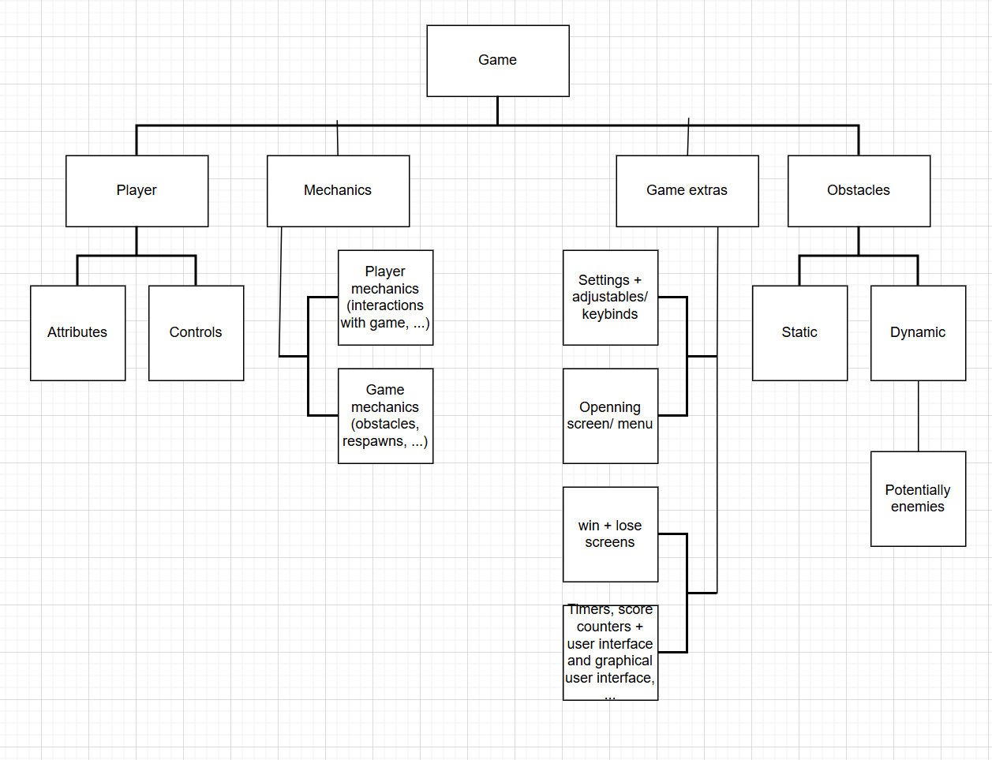

### Thinking Logically

This allows me to understand and plan out how to produce a solutions to each of my subproblems as broken down above in Thinking Procedurally. This might include game logic like how different obstacles function, as well how the player’s movement works:

* When a player jumps, they cant jump again until they fall onto a solid object, unless they have for example double jump (if double jump is implemented)
* When a player is harmed, their health is reduced by a certain amount, if they die, i.e health is seen to be 0, their lives counter is decremented by 1, and if lives counter is checked to be 0, they have to restart and a screen that displays their loss, score, how far they made it, etc. is displayed. Else if the player successfully beats the level, they see a win screen instead.
* When the assigned button is pressed (by default ESC), the menu screen will show, allowing the player to pause the game and choose other options that are outside the main game (like opening the settings).

### Thinking Concurrently

By thinking concurrently, I can identify issues with the current solutions and fix them. This is important since I know I will have a scoreboard and timer (a simple scoreboard and the sun that rises and falls to indicate timer), therefore I already know that I need these two features to be updated at the same time since as the player is obtaining score, the timer is also moving.

## Stakeholders

The game’s graphic design will be very similar to the three games mentioned earlier; arcade and retro style. This art style is simplistic and useful for my game because it ensures that players are more focused on the core gameplay rather than how the game looks. This is important since the point of the game is to improve problem solving skills, if the player is too distracted by a beautiful graphic design, they won’t be fully concentrated on solving the problems that are presented in the game. By having the player’s focus set on the core gameplay itself, the game will be able to more accurately assess a player’s current set of logical reasoning skills, and improve them more efficiently. The game is also intended for computer and laptops, this is because PC keyboards allow for flexible controls. Furthermore, a keyboard allows for a better approach to improving problem solving because if I were to implement mobile controls for example, I would have to use icons or decals to indicate what each control does, and this doesn’t really help the player in developing their mind because they will easily be able to tell what each control does, whereas forcing the player onto a keyboard where they don’t know what each key does, allows them to think about how they can use the keys to beat the game. Considering these factors, the game will be most suitable for audiences in the age group of 7 years to 18 years. This is because since the game is going to be available for PC only, and children of these ages are in school where computers are used more often, they will be able to play. The majority of children in this age group also likely already know the alphabet, so the keys on a PC keyboard will be understandable making them easier to understand which key does what (which will be explained in the tutorial of the game). Also, since some text is present in the game, the audience should be capable of basic reading which this age group should be capable of.

### Interview 1

I have chosen a friend who is an avid gamer to answer my questions for this interview. He is interested in a platformer game as the ones that already exist are mostly out of date.

For my first interview, I want to get down the core parts of the game, to get an idea of what features I should include, and some other ideas and issues that that my stakeholder would like me to address in my solution, like what kind of things my interviewee is looking for in a game, what makes it enjoyable and allows them to learn at the same time, and more. This first set of interview questions gives me an idea from the player’s perspective, what they need to be able to experience in order to be willing the play the game and use my solution.

Q = question asked (red)

A = answer given by interviewee (green)

Interview:

Q: For a video game, what is more important, the enjoyment you get out of it, or what you learn from it? Why?

A: what I learn from the game as many well built games teach lessons that can help us in life while still enjoying the game, for example I have played a game where you have to do mental math to calculate projectile trajectories called “war thunder”. This, although minor, has helped me practice mental arithmetic which is quite useful in daily life like going shopping.

Q: Do you think sound play is important when it comes to single player games? If so are they more important because they provide a lasting memory / reminder of the game, or do you find them important for the information you obtain from them in order to progress in the game?

A: I find the information I obtain from sound more important because I can use them to determine my next course of action. For example when I played slasher games before, certain sound queues informed me of if an enemy is attacking and what kind of attack it is, so I can plan out my next move. I don’t think it makes a lot of sense to listen to the sound in a game for the memories because in my opinion the sound is literally there to tell you what is going on.

Q: what about a game keeps you engaged and willing to continue playing after the first hour of playing it? What makes it addictive?

A: I think a vital aspect of a game that makes me want to keep playing is how many and the types of choices and options you can make as the player, I don’t like it if the game is really static and there is only one way of doing things, as I think this restricts the player from using their imagination and makes every playthrough very monotonic. The story is also pretty important to me because without an engaging story, I just feel like I’m playing a generic platformer, which I can do on any already existing platformer game.

Q: when it comes to graphics and visual effects, do you think these are more important than the core gameplay, or do you think both are equally important? Give reasons

A: I personally think they are equally important --- they actually depend on each other, like I think the better the core gameplay is, the more important the visual effects are since the graphics are there to bring life to the game and provide emphasis. If the game mechanics are good then surely good graphics would compliment the gameplay to make it more engaging and more refined. With that said, for simpler games like platformers I think the graphics aren’t too important, but they have to be satisfactory to the point where the graphics express the gameplay and game mechanics correctly such that the player knows what is going on in the game.

### Interview 2

For this interview I asked the same interviewee in interview 1. The objective of this interview is to determine what is aesthetically pleasing to see in video games, as if the graphics aren’t good enough, players will think that the game is of low quality and will be less engaged, as for example, if a game is just circles and blocks, it isn’t very interesting in this era because the circles and blocks don’t really bring any excitement.

This allows me to pick out how my game’s graphical design will work out. By doing this I can abstract what kinds of graphics from development and sounds a player would find plausible and appropriate for giving them information on what is going on in the game.

Interview:

Q: Do you think simpler sounds are better, or complex sounds for providing information to the player? Why? Do you think simpler means more distinguishable for example?

A: Simple because if they are too complex, that means the sound has too much to it which makes it harder for players to recognise them because there is more going on, by making it simpler, I think you could have more distinguishable and a larger variety, because if all the sounds had like a similar duration, then the player would also have less to memorise in order to recognise sound queues because they don’t need to worry about durations which means you can have the player encountering multiple events consecutively and have them still be able to react to what is going on. By making it complex the other issue I have is that it doesn’t really fit the tone of the game since I know it is going to be a platformer game.

Q: Do you think sound effects should be paired with visual effects to provide a better indicator of different events happening in the game, or do you think this shouldn’t be the case as it would make the game too easy? Why?

A: I think it should be well rounded because if there are too many visual effects, then it becomes painfully obvious to the player what is going on and takes away the contribution needed from the player to play the game, this means fewer chances for the player to learn and apply things they have learned which is the objective of this project. But I also think without enough visual effects, the gameplay will feel one-sided as the player is only relying on sound to react to certain things. Basically the visual effects should be subtle because they are easier to determine than sound.

Q: Do you think the mood and tone in the background /pathetic fallacy is important for setting the game’s tone and how the game teaches its lessons? Why?

A: I think there should be a bit of background tone to help with understanding the situation of each level, it also brings engagement as there is more going on and more for the player to inspect and think about, but again, if there is too much , it will end up causing problems like with the previous question, over do it and the player will be distracted and lose focus of the main objective, which defeats the purpose of the solution.

### Interview 3

For this interview I want to know more about any specific preferences and needs that my stakeholder wants in the game, like how they want to see their character behave, such as when they win on a level or when they lose, or when they perform different actions like when jumping for example.

Q: How would you like to see the character animated? (Jumping, losing, winning?)

A: For jumping I think both his arms should flail up to exaggerate it and show he is jumping, for losing I think if he dropped down to his knees and started crying would be a good way to animate it because it makes it very clear the player has lost, and for winning the opposite, have him get a crown on his head and hold a trophy while jumping.

Q: how many lives do you think you should have before you are reset to the beginning? Depending on your number, why do you think this? Do you think you picked the number of lives based on the difficulty that it has on the game and why?

A: I think that the number of lives should change depending on difficulty of level, so for the first few levels, start off with unlimited in the tutorial or first level so it’s fair and players can figure out what’s going on first before heading into the larger part of the game, then have them start the actual levels with 5 lives, as they get to harder levels give them slightly more so that there is still balancing, but at the same time enforces them to be cautious with how many lives they have to work with.

Q: what kind of sounds do you want to hear when the character performs certain actions (dying, jumping, running + walking, landing after jumping, etc)?

A: for dying I think he should yell or scream “ahhh” to make it clear to the player they died, for jumping maybe a hop noise, like similar to super mario games, for walking and running I think it should be simple footsteps that don’t interfere too much with the rest of the game’s sound so the player can still hear and react to other events going on. For landing maybe a grunt, anything simple for the movements in my opinion would do.

Q: do you think once the player loses all their lives should all their data be reset and they have to start again, or do you think they should only be reset to the first level but keep certain things, if the second option, why and what kinds of items do you think they should maintain?

A: I think there should be checkpoints on lower levels so that the player can get a better grasp of the game faster, so that every time they lose all their lives, they will drop back to a previous checkpoint in the last level and don’t have to start entirely from the beginning since that would be boring and locking players who cant make it past the easier levels permanently in the lower levels, but then once the player reaches the harder levels, every time they lose all their lives, they just get reset to the last checkpoint of the easier levels, so they can immediately start off with playing on the easiest of the harder levels, this will prevent players from being discouraged to try again every time their progress is wiped.

## Existing Solutions

One game that is already a solution to my problem is ‘Dead Cells’, it is a fighting-adventure game where the player traverses multiple levels each with a different kind of layout and obstacles, along with unique enemies in each level. At certain points of the game there are also bosses. The player must reach the end of each level (a door) before they can proceed to the next level. Each level also contains other points of interest such as item/collectible shops and secrets/easter eggs. The game is 2 dimensional and seen from the side of the player and involves the player collecting weapons and upgrades to defeat enemies easier. Some of the player’s base features are the ability to run, attack, jump, roll (a defensive option that provides something called ‘invincibility frames’ (i-frames) where while the i-frames are active the player takes no damage and “dodges” all active attacks landing on the player), sliding, and drop slamming (where the player can negate fall damage by accelerating while falling and slamming into the first horizontal platform they fall upon). There are also many obtainable features that the player can obtain and keep. Every time the player defeats an enemy, depending on the enemy, they will drop a reward for the player, usually this reward is a form of currency the player can use (cells, which are all lost on death by the player as well) but occasionally, the reward may range from collectibles to attribute upgrades to weapons. If the player dies, they lose almost all of their possessions and are reset to the very beginning of the game. This provides some form of reward but also punishment which forces the player to be smart about how they play throughout the game. The game also features a healing system where the player has a number of ‘healing flasks’ which they can drink to regenerate health points, and these flasks may be refilled in the intermission stage between levels every time they complete a level without dying, also enforcing a sense of strategy as player must conserve and use their flasks at suitable times.

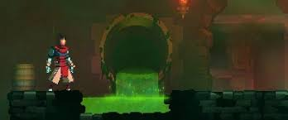

Acid pool in a 2nd layer level ‘Toxic Sewers’

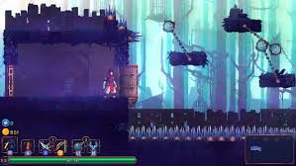

Swinging spike balls (dynamic obstacles)

Spikes

In the 2nd layer level ‘Promenade of the Condemned’

Above are two examples from the game. They are two separate levels and have different types of obstacles, in the first one acid pools are a kind of obstacle where if the player stays in them, they take damage over time, whereas in the bottom example, the obstacles distribute instances of damages for each time the player comes into contact with them. Below is an example of the player taking damage, a border with a fading red hue is seen to indicate to the player that they are taking damage, their player also flashes red.

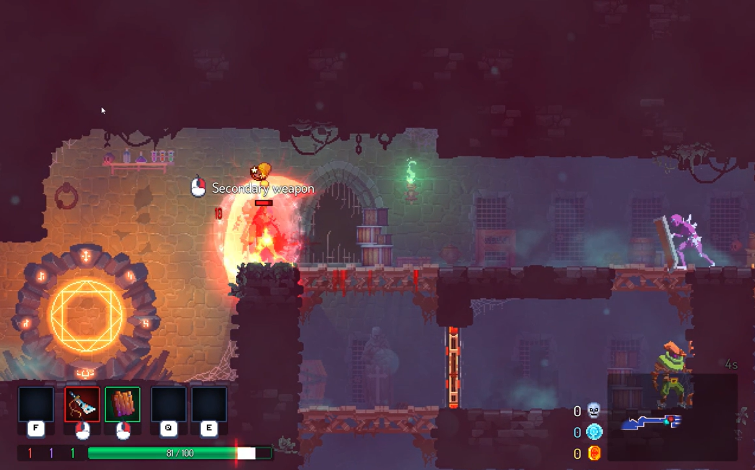

Player flashes red when hit, and the white shows the health that was lost when player was hit, the red vertical line shows where there health is now

If compared with the previous 2 images, you can see that the screen is redder here, this shows the player just took damage

Every time the player accomplishes something new, they are rewarded with an achievement as shown below:

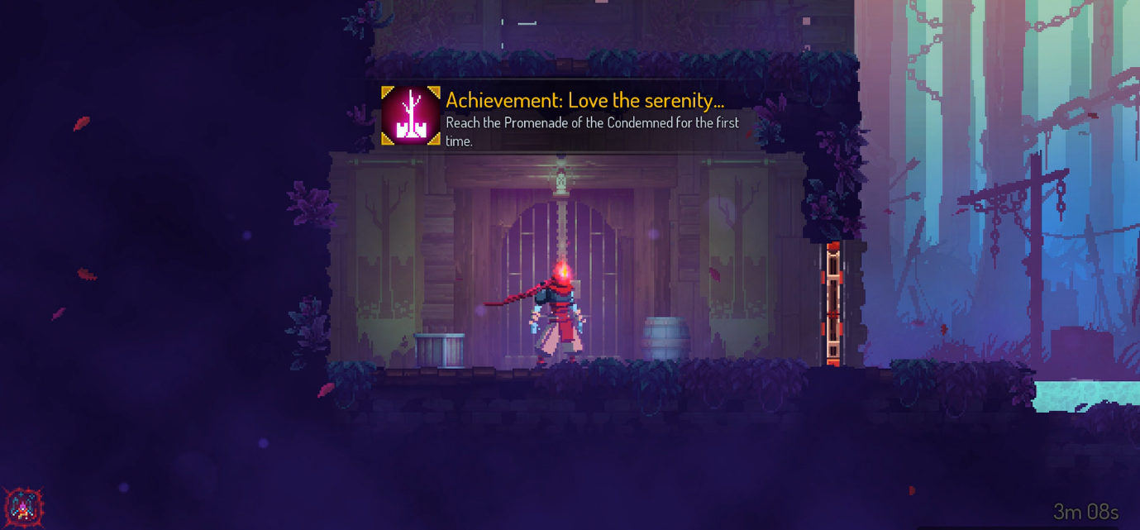

Achievement prompt

Everytime the player loses i.e dies in dead cells, their screen fades black and are displayed a message to tell the player that they lost and have to restart:

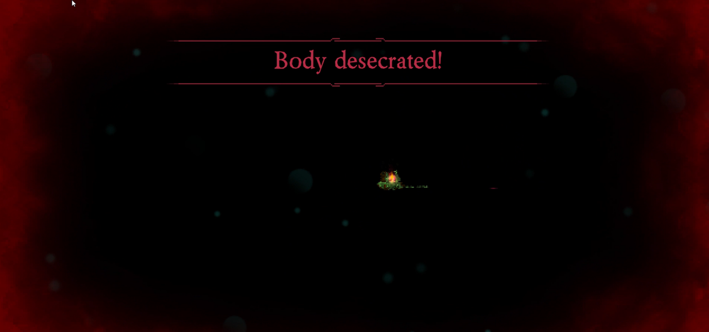

Lose message with emphasis as seen by the 2 red horizontal lines

Black screen

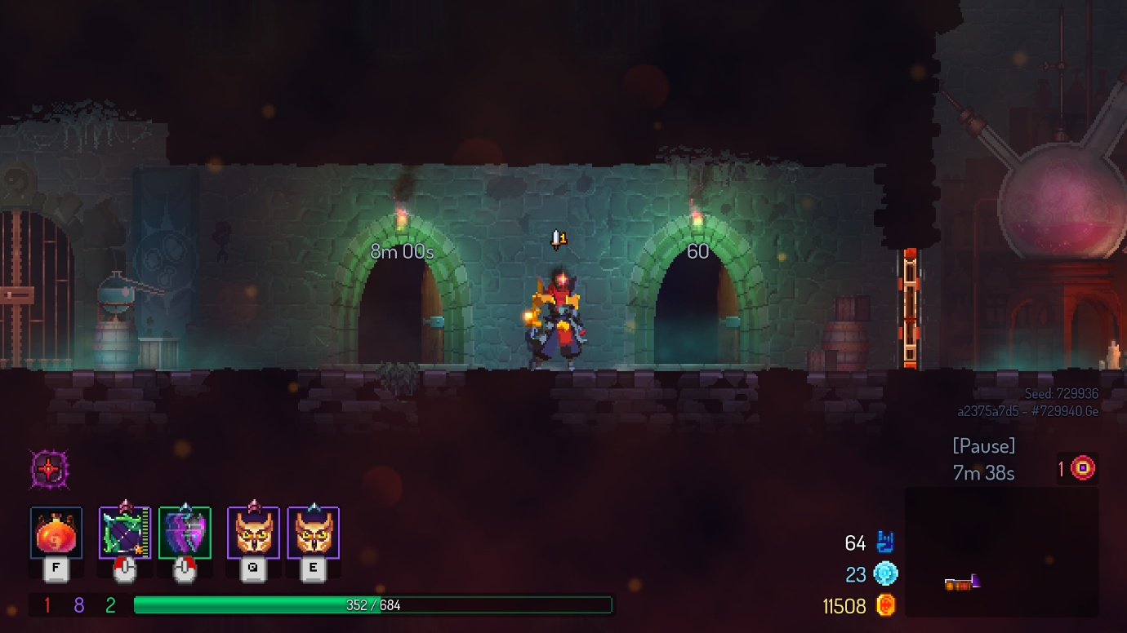

Dead Cells has a timer system, where certain levels reward the player for completing them in within a time limit

The above shows a feature in Dead Cells, timers, this provides a cut of difficulty which if the player is able to cope with, rewards them.

Below is a picture of the Dead Cells menu screen, it has many options which allows the players to pick what things they want to do, for example select difficulty, adjust settings, or play a daily challenge game mode.

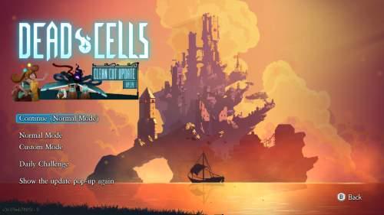

Other game modes

Play, with the selected difficulty

Game mode options, difficulties

A second existing solution is the Super Mario Bros. game. In this game the player plays through a story as either one of two characters. It is a classic platformer game and the player progresses by traversing each level, as they move the player’s screen shifts along to keep the character in view. Every time the player encounters a coin, if they touch it they receive the coin and that is incremented to their score on the top left of their screen, shown as a coin counter.

As mentioned earlier, Dead Cells also rewards players for defeating enemies or accomplishing certain tasks. These ‘drops’ or ‘collectibles’ may come in different rarities as shown below.

The player’s score (cells, the blue round icon) and the amount of currency they have below it

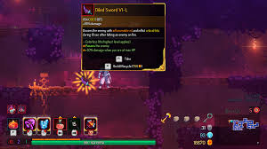

Item/drop description with different ‘pips’ which give the item a few extra, unique features such as the ability to poison enemies

The item drop itself, all items have some sort of glow around them to indicate that they can be picked up, different colours mean different rarities of items or different types. E.g yellow is legendary, red is for a certain class of weapons.



The world’s view follows the player as they move, so that they can continue to play through the map even if they are on a smaller resolution device

Every time Mario touches a coin, you can see the coin counter increases

The benefit of the world scroll is that the levels and maps in the game can be made as large as the developer wants to, if there was no world scroll players would be restricted to the field of view available from the resolution of their devices, which limits the content within the game.

The third solution to my game is trap adventure 2, which went a creative route for a platformer game and has many obstacles designed to behave differently depending on how the player plays. In terms of core gameplay, it is essentially the same as Super Mario Bros; the player travels through multiple levels, avoiding obstacles via parkour, once they reach the end of the level, they are brought to the next, unlike the previous two solutions however, trap adventure 2 is much more generous with lives to compensate for it’s difficult levels. The dynamic obstacles are hidden and only appear when the player fulfils certain conditions, below is an example of a hidden spike as well as a very generic but acceptable lose screen:



Simple but effective game over screen which clearly indicates to the player that they lost.

Only when the player gets close enough to the obstacle, do the spikes appear to knock the player off into the pit below.

Below are some examples of features from both Super Mario Bros and Trap Adventure 2 that I intend to use. These show the lives (tries/attempts left) and timer features respectively.

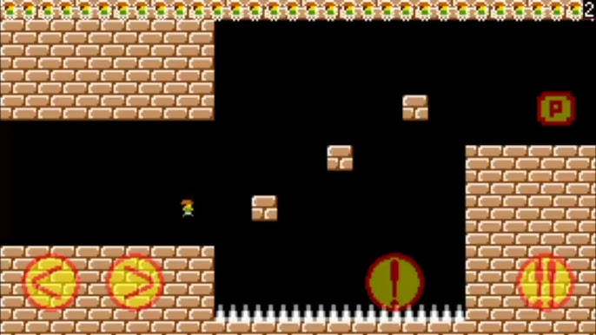

The small character images show how many lives the player has left.

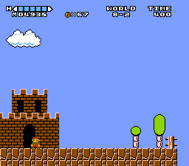

The top right corner has an indicator that shows how much time the player has left to complete the table

All 3 existing solutions also feature a settings feature which provides the player with the freedom to play the game with or without certain minor features:

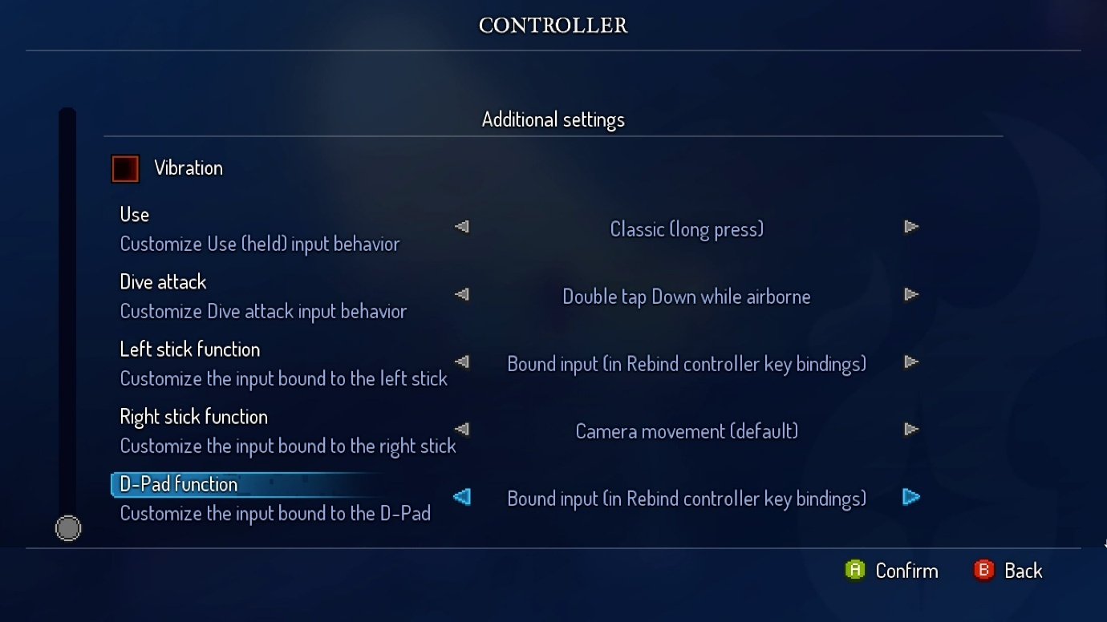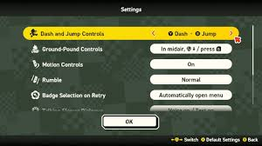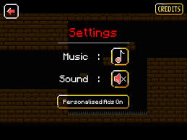

Dead Cells has the most freedom when it comes to settings, allowing the player to play the game in whatever way they want

Trap adventure 2 has a very simple settings as it needs to maintain game difficulty

Super Mario Bros’s settings provide certain quality of life options

## Essential Features

The features that should be completed as part of the original solutions will include:

* Static obstacles – spikes, lava / acid pools, spiked walls, …
  + This is so that there a basic obstacles that the player has to memorise on how to avoid, this will train their muscle memory which can then be used to help them think more efficiently, as once they encounter new dynamic obstacles, they will have a more procedural way of thinking up strategies to avoid the sentient obstacles, training their problem solving skills.
* Dynamic obstacles – disappearing platforms, hidden spikes, traps, …
  + These are meant to test the player’s logical thinking skills as they will always be made so that the obstacles cannot be avoided via playing the game brute force or by obvious methods, this way the player has to get creative and think about how to avoid them.
  + This idea has been taken from Dead Cells and Trap Adventure 2, which both have a great difficulty meter due to having dynamic obstacles
* Multiple levels that get harder
  + This provides a challenge to the player so that they can continue to improve their reasoning and also keep the players engaged with plenty of content.
* Settings
  + Includes key bind changes, and other generic settings a game would have like volume, potentially lighting, this way players who aren’t comfortable with the default game can change it to a certain extent without affecting core gameplay.
* Health and lives counter
  + This is an indicator for the players so they can keep track of how much health they have, and how many lives they have so they can be more or less cautious depending on how far away they are from losing.
  + I have taken inspiration from the 3 existing solutions, however have decided to adapt on Trap Adventure 2’s system because Dead Cell’s system is too harsh as players will lose the entire game immediately upon death, whereas in Super Mario Bros it is too generous.
* World scroll
  + World scroll is the camera view the player sees, so as they move throughout a level, they can see different parts of the map within the boundaries of their screen size, this allows for larger map / levels.
* Character with movement options and certain actions – running jumping walking
* Sound effects
  + Provides information to the player so they can use it to help them beat the game
* Score counter
  + An indicator that displays the player’s score so they know how far they are from beating a level in the best and most efficient way possible.

## Limitations

Extra features if the essential ones are successfully implemented well and there is enough time to add extra features:

|  |  |  |
| --- | --- | --- |
| Feature | Reason for it’s addition | Reason it’s a limitation |
| Bosses and enemies with special abilities to hinder the player’s playthrough | This would add a next level of difficulty to the game as well as bringing it more life. This way players have to both compete against obstacles that are premade in the level, and against computer which may act differently depending on the situation, forcing the player to adapt more. | The project has to be completed within a time limit and I don’t have sufficient knowledge and time to learn how to make a good quality artificial intelligence + pathfinding + decision making for enemies |
| Player abilities | They would bring the player more reason to play the game as children like to see cool abilities and visual effects. More importantly however it enables players to think creatively on how they can use the abilities to beat the game. | A bit pointless unless the above feature is added because the main point behind this idea is to deal with the enemies, for completing a platformer game it is more or less optional and the abilities’ side usage. |
| Create your own level game mode | This would give players who have completed the game and felt there is little replayability more reason to continue playing the game. It also encourages players to think creatively which in turn encourages and teaches other players who player community made levels to think creatively and learn different strategies. | This requires the game to be made multiplayer and I don’t have that much time to learn how to create a multiplayer feature because without this feature, there isn’t much point to playing your own level as you already know the layout of it. |
| Mobile inputs | It would enable a larger audience to be able to play the game | With the number of controls in the game, it wouldn’t be possible to add enough buttons on a mobile screen to ensure all the controls are covered, at least not without much of the screen being covered and unseeable for devices that are any smaller than an iPad. Due to the project also having a time limit I don’t have enough time to learn how to do this since I also have A levels. |

Hardware and Software limitations:

|  |  |  |  |
| --- | --- | --- | --- |
| Hardware/Software | Limitation | Reasoning | Reason it is a limitation |
| Hardware | There may be many obstacles and hidden ones on higher levels resulting in large memory cost and potentially slowing down performance | On harder levels there has to be more content as this is to ensure harder difficulty and players are tested sufficiently and effectively. | Not all players have access to high-end devices, including me as I am making this game on an old laptop that is also not in its best state. |
| Hardware | The game will only be accessible to devices with a keyboard | The controls will be made using keyboard keys which are easily implementable in visual studio code | Not all players will have a keyboard or a computer / laptop so it won’t be playable for them, I also can’t necessarily make a touch screen and mobile inputs feature because due to the time limit I am unable to learn how to make one |
| Software + Hardware | High quality lighting, visual effects and graphics | Especially for the targeted audience, children and teenagers, graphics are very appealing and may encourage more players to play | Pygame doesn’t exactly have the tools to make super high quality visual effects, even if I was able to draw very detailed map designs, it would also be problematic because that would be very GPU dependent and not all users will have access to this, including myself which makes testing also an issue |
| Software | Game sharing / Co-op game modes | Allows more people to play together which may be beneficial for promoting and advertising the game to a larger audience. | Visual studio code is better for writing code, it isn’t the best integrated development environment for producing games + the reasons from earlier (time restrictions) |

## Software and Hardware Requirements

|  |  |
| --- | --- |
| Hardware | Explanation |
| Computer type device (PC, laptop, … anything with a keyboard) | The controls are keyboards keys, and the players can’t make inputs and play the game if they cant access the controls. |
| Monitor/screen/output device | The game must be displayed to the player so they can see what is going on and what they are doing otherwise they won’t be playing the game. |
| 8-16GB of RAM | This is the average computer’s RAM capacity, since the game has a decent amount of obstacles and content (drawings, map designs, etc.), the player’s computer must be able to handle this without crashing so the game can run smoothly |
| 1.6GHz processing speed or above | Minimum requirement for visual studio code to run, if they can’t open visual studio code, they can’t execute the code to play the game |
| 1GB of secondary storage | Sprites will be used in the game, but there may be quite a lot of them for the character, obstacles, maps (as modules are going to be used), and more. The large secondary storage is to ensure for this game that no matter what content is in it, there is enough secondary storage to support it. |
| Output device (headphones, speakers, earphones, etc.) | The game has sound effects, so the player needs to be able to hear them to get information on what is going on in game. |

|  |  |
| --- | --- |
| Software | Explanation |
| Visual studio code | The game is written in VS code IDE, to run it the player imports the game’s files and runs them in VS code, allowing them to play it |
| Pygame library | Most of the game’s code is written using pygame’s library, so the player can run the game as their computer can then understand what the game’s code is instructing to do. |

## Success Criteria

|  |  |  |  |
| --- | --- | --- | --- |
| Number | Criteria | Explanation | Reference |
| 1 | Opening screen | To show player the game has started up | Feature in all 3 existing solutions. |
| 2 | Static obstacles | Standard, obstacles for players to overcome, must have in a platformer game like this | Dead Cells obstacles |
| 3 | Dynamic obstacle | Obstacles that require more critical thinking and require a strategy to get around | Trap adventure 2 feature, interview 1, the stakeholder likes a game having more difficulty, Dead Cells obstacles |
| 4 | Levels with different map designs | Brings variety and a form of progression to the game, so it has a story and can be played for a good amount of time before the game is completed |  |
| 5 | Controllable player with movement | It is a platformer game so the player has to be able to navigate the game somehow |  |
| 6 | Menu + Settings | To allow the player to change parts of gameplay to their liking, and to accommodate for certain player’s circumstances, like people who may have certain keys on their keyboards that don’t work so they can re bind controls |  |
| 7 | Health + lives system | Provides a permanent-death system which in turn enables a sense of difficulty and forces players to plan out and strategise how they play the game safely | Interview 3, trap adventure 2 feature |
| 8 | Loss + win screen | Provides the player with a sense of achievement for completing parts of the game and encourages them to play on | Dead cells feature (loss screen), interview 3 |
| 9 | Respawn system | Linking to 8, the player has to be able to continue playing after they lose all their lives. | Interview 3, Super Mario Bros, Trap Adventure 2 |
| 10 | Timer | Provides difficulty, as the project aims at training problem solving skills, efficiency is also paramount, this allows the game to take the players’ critical thinking skills to the limit | Dead Cells feature, Super mario bros features |
| 11 | Tutorial mode | Teaches player the basics and how the game works, players cant play the game if they don’t know what it is |  |
| 12 | Background designs | Expresses the difficulties of different levels, encourages players to determine the difficulty since if they were just told, it would be too easy |  |
| 13 | Collectibles/obtainable items | Allows players to obtain achievements essentially, a reward system otherwise players will think the game isn’t worth playing | Dead Cells |
| 14 | Sound effects | Provides information to the player on what is happening in game, useful for helping players strategise | Interview 1 and 2 |
| 15 | World scroll | Important to allow larger maps and levels to be created and played by players, as it would be hard to fit a large level into a tiny screen, which makes small details undetectable. Without this players would see the whole level on one screen that doesn’t move and the character of the player will likely be very small to be seen, making the game harder to play than it already is | All existing solutions |

# Design Stage

## Decomposition

In this section of the design stage, decomposition will be used to break down the problem and identify certain aspects of the game that need to be completed and then put together to obtain the finishing product. This simplifies the game’s next development stage (implementation) as I will have a clear list of many very small problems that I need to complete, after which I can simply put the solutions together to finish up the game.

I have made in depth diagrams for the mainly problematic branches above to plan out what each branch might need and what must be considered and understood in order to be implemented into the game successfully.

Starting off with the menu, a part of the Games extras branch as shown above:

Menu – the piece of code that will make the functioning and draw the menu onto the player’s screen.

* Pause – a feature of the menu, if the menu is open, the game is paused so the player can freely access the menu or adjust the settings without the game continuing. This is important because if the player is busy adjusting settings for example, it wouldn’t make sense for the game to continue playing in the background. This is because if the player is in the menu, they are therefore not currently playing the game, so they are wasting processing power, and secondly, the player’s data may be updated as the game is running while they are trying to use the menu, which would be unfair on the player if for example, they lost a life while they are trying to use the menu.
  + Un pause – when menu is closed, the game is un paused because the player has gone back to the “currently playing the game” state, as they do not need the menu anymore.
* Controls guide / manager – contains information on controls for the game
  + Controls list – provides a list of controls the player can use in case they forget or don’t know what different key inputs do
  + Controls explanation – next to each control in the control list, there will be a small description that describes to the player what each control does and perhaps some things to note for the player when using the controls. This is so the player can think about how to make the best use of each control, for example, jumping to get from one platform to another.
* Menu screen design
  + Buttons – clickable / interactable areas that perform a function, such as opening the settings or closing the menu. This is so that players who are more comfortable with pressing buttons to access parts of the game will be able to do so. The menu will be openable both via a keyboard input, or by clicking a button, this provides variety, and in case the player forgets the keyboard shortcut, they can still open the menu anyway without issue.
    - Settings – this is one of the buttons, clicking on this button will allow the player access the settings, so they can adjust parts of the game if they want to.
    - Close menu – this allows the player to close the menu if they forget the keyboard shortcut to close the menu.
    - Open/close control guide/manager – while inside the menu, the player will be able to open up the screen that has all the information about the controls.

* + Background screen – as I am not sure how to literally make a menu that is opened, the idea is to essentially cover the entirety of the player’s game screen with a background, then draw and add the menu’s functionality and objects onto the background screen, which essentially creates the illusion of a menu, except it actually is a menu.
  + Menu title – this is drawn on most likely on the centre towards the top of the screen, to indicate to the player that they are in the menu. If this wasn’t here and for example the player accidentally opens the menu, they might not know they are in the menu and think the game has been bugged and will not know how to return to the main game.

The second expanded diagram I have included is for the controls and mechanics of the game:

Mechanics and Controls – the structure and necessities needed for the pieces of code that manage and work on the mechanics and controls of the game.

* Base mechanics – mechanics that are available to the player by default and will always be there, this is needed as the player wouldn’t be able to play or interact with the game if there is nothing for the player to do.
  + Movement – a very fundamental piece of the game is being able to move as it is a platformer game, if the player can’t move then they aren’t really playing the game.
    - Keyboard key “A” input – pressing the “A” key on the player’s input device (keyboard for this game) allows the player to move to the left.
    - Keyboard key “D” input – pressing the “D” key on the player’s input device allows the player to move to the right.
    - Keyboard key “Spacebar” input – pressing the spacebar allows the player to perform a jump, gravity is applied as soon as they start jumping so they fall back down, and they can not jump again until they are standing on a stand able platform. This is also important as the game does not have a freely omni directional movement system, so they cannot just fly around the map, the jump mechanic makes the player’s movement feel more realistic as a character in a platformer game ideally should not be able to fly, as this would defeat the purpose of completing the parkour and obstacle courses in the game. This also means there is no key input that allows the player to go down, as the player realistically isn’t able to manipulate their gravity.
  + User interface “UI” – on screen mechanics that allow the user to interact with certain parts of the game.
    - Open and close menu button – allows the player to access the menu even if they don’t know the keyboard short cut to open the menu, by clicking on the button
      * Menu buttons – allows player to interact with menu, explained under menu’s structure diagram
* Interaction mechanics and functionality – the games response to the player’s actions, this is so that when the player performs an action, that action is actually carried out and does something in game that provides a result, for example if the player moves into a block, they won’t be able to walk right through the block as they would be colliding with it.
  + Movement collisions – broken down into two separate directional collisions. Movement collisions manage and monitor how the player’s character is interacting with the game, for example if they stand on a platform, it ensures they don’t fall through by continuously resetting the player’s position to the boundary of the platform’s side the player is on or at.
    - Vertical collisions – this set of instructions /code will ensure the player does not fall through a platform they are standing on or falling onto, and ensures they cannot jump through a solid platform from below.
      * Jump collisions – when jumping, ensures player don’t jump up and through a solid platform (bottom collisions)
      * Falling collisions – when falling, ensures player doesn’t fall through from top to bottom of a solid object (top collisions)
    - Horizontal collisions – when the player is moving sideways, if they hit a block, they do not go through it from the side they hit it from. i.e if they walk from the right, to the right side of a solid object, they do not start walking into and through to the other side of the solid object via the solid object’s left side, and if they are walking from the left to the left side of a solid object, they don’t walk into then through the solid object from its right side to the left.
      * Moving left – when moving to the left (the player), if they move into a solid block, they don’t go through (right collisions)
      * Moving right – when moving to the right, if the player hits a solid object, they don’t go through the object (left collisions)
  + Timer pause – when the player goes into menu for example, the game’s timer is paused because it wouldn’t be fair on the player to lose their time remaining to complete the level when they are trying to for example, adjust a setting in the menu.
  + Stop movement and drawing on pause – when the player opens menu the player’s positional data and general data is frozen so they cant for example, somehow lose a life while the game is paused, or lose score. (maybe be able to reduce load on CPU?)

The next expanded diagram describes and lays out how the player’s class and systems will be made and implemented.

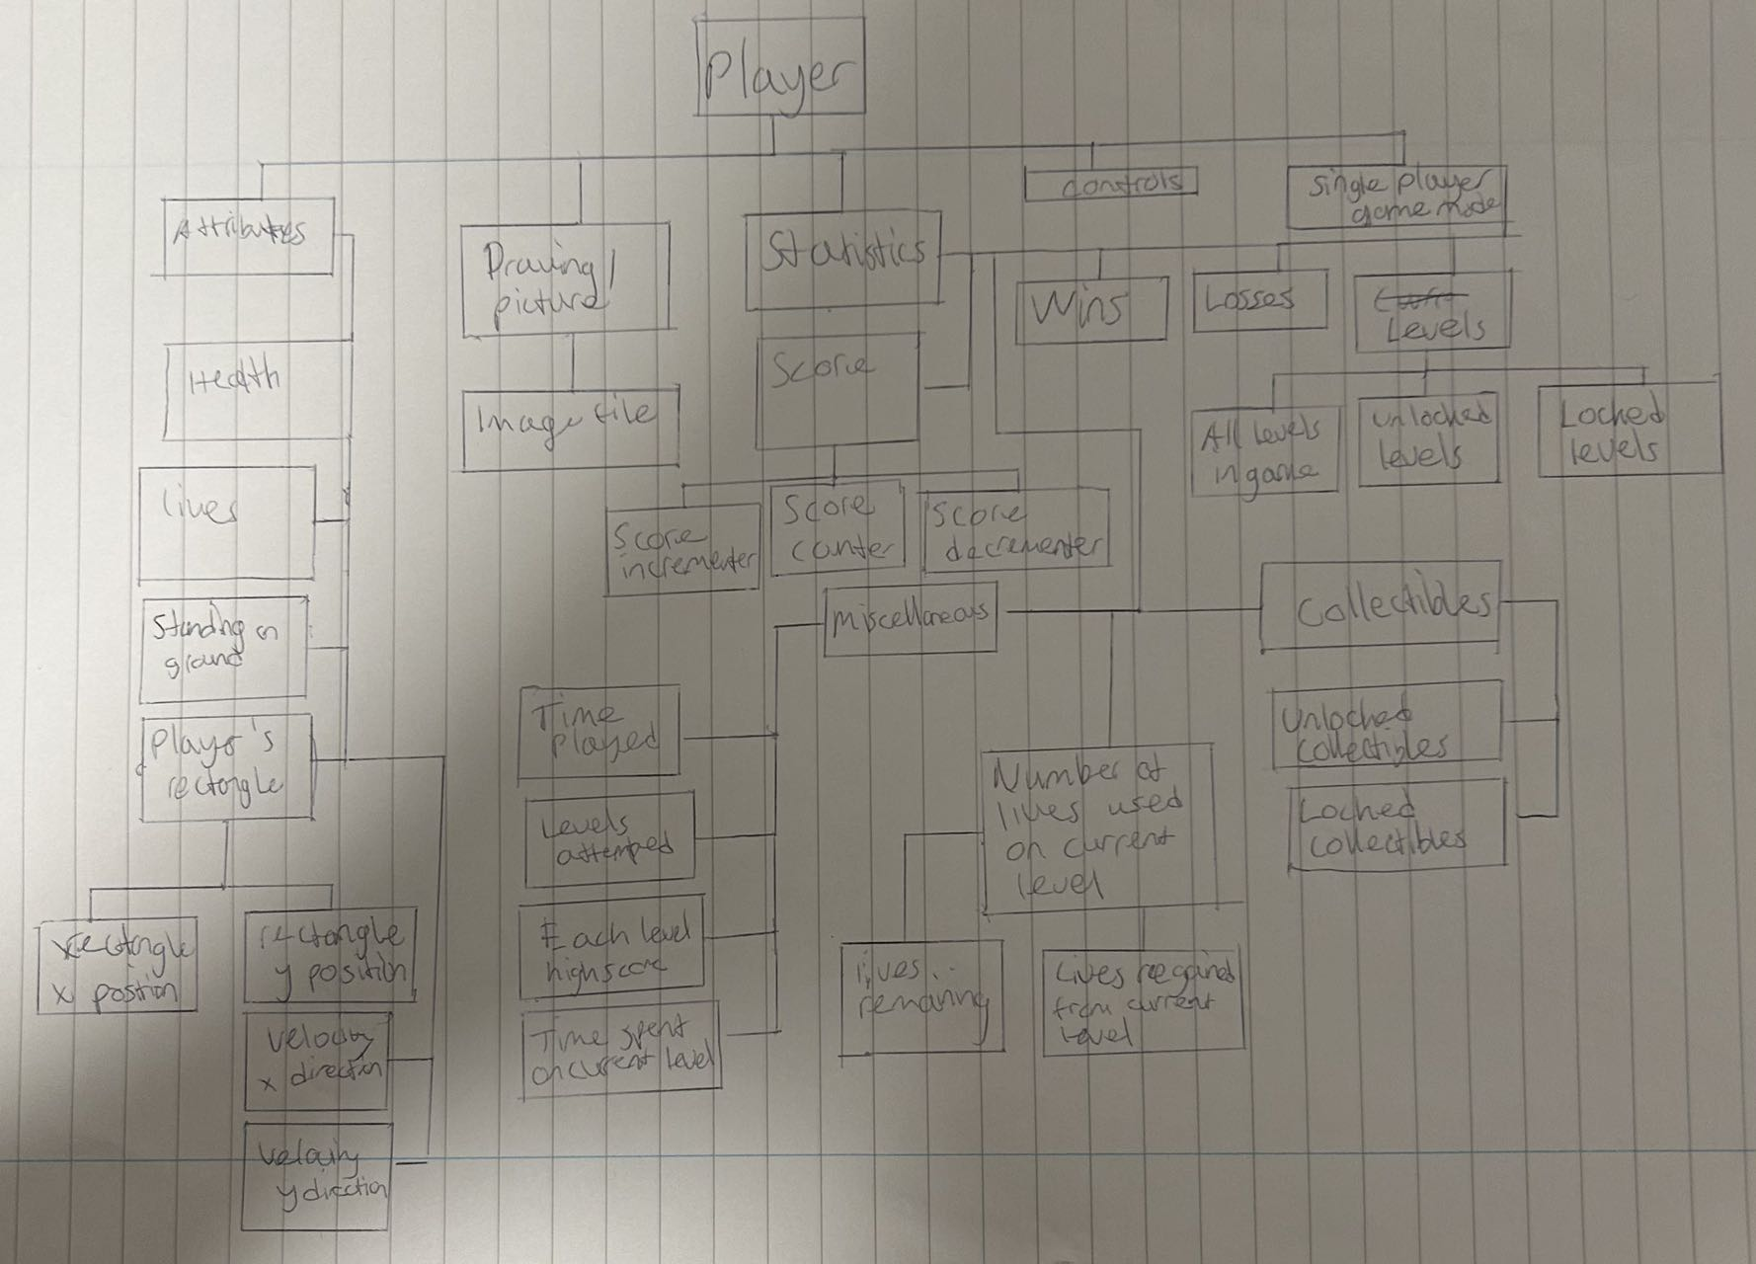

Player – the class that the player’s character will be made from. This is what the user will use to play the game, they will control this player.

* Attributes – this part of players contains all the information about the player’s character. This is so that the player’s character can function and interact with the game properly, and it also has extra information that the player may want to view to help them complete the game. Most of these attributes’ are encapsulated as the player does not need to know for example, the exact size their hitbox.
  + Health – this is fundamental to the player’s character, as it will be used to operate on the lives system and loss/defeat system for the game. It also helps the player learn to be cautious with what they do and think thoroughly before acting as to make sure they don’t make irrational decisions that may hinder them from completing the game. If it reaches 0 then the player loses a life and they’re progress is reset to the last checkpoint.
  + Lives – this is a counter of how many attempts remaining the player has to beat the level / game. It helps provide a challenge to the game’s simplistic genre. If this reaches 0 the player loses the game.
  + Standing on ground – this attribute is a Boolean value that is used to determine if the player will be able to jump or not, it wouldn’t make sense for the player to be able to continuously jump as much as they want while in the air because that would basically be allowing the player to fly, defeating the purpose of completing the game.
  + Players hitbox – the attributes underneath this set is used to check for and deal with player collisions with objects.
    - X position – the horizontal position of the player, the value is a part of the top left corner of the player’s hitbox.
    - Y position – the vertical position of the player, part of the top left corner of the player’s hitbox.
    - X velocity – private attribute that is used to update the player’s position, meaning if they are moving left or right, the x velocity will have a value which will be added on or subtracted from the x position to draw and show that the player has moved horizontally in a direction.
    - Y velocity – private attribute that is added on to the player’s y position, this enables the player to jump whenever they press the jump control, and fall whenever they fall from a platform, or after jumping.
* Drawing of player / picture – this is one of the most important parts of the player as if the player isn’t drawn on, then the user does not know what is going on in the game because they don’t know if their inputs are doing anything. Drawing the player shows the user the results of their actions.
  + Image file – this may be added on top of the player’s drawing to give a more detailed and interesting appearance to the game, as drawing with pygame’s simplistic shapes may be boring to look at.
* Statistics – extra information about the player that isn’t necessarily used to control and get the player to interact with the game’s systems, but may be important for the user’s experience. Some stats may be displayed in the menu as they aren’t relevant to the majority of the gameplay, for example wins and losses, the player doesn’t really need that information in order to beat the game, they are just information.
  + Score – gives the player an idea of how well they are doing, so they know if they are close to beating the level they are on, or if they need to change up their strategy.
    - Score incrementor – increases the player’s score value every time they perform an action that increases score (i.e gain a collectible).
    - Score decrementor – decreases the player's score value every time they perform an action that decreases score (i.e lose a life).
    - Score counter – displays the score value of the player as a number to the player on the drawing screen. This lets the player see how well they are doing. It is updated every frame cycle and after the player’s attributes have been updated, as the player has to gain the score, before the score can be updated as updating the score before the player gains any provides out of date information to the player.
  + Wins – number of times the player has won the game.
    - Every time the player’s wins is increased, a background will be drawn on to the screen with drawing to indicate to the player that they beat the current level or game.
  + Losses – number of times the player has lost the game.
    - Every time the player loses all their lives (a loss), the player will be presented with a screen that tells them they lost, so they know they have to restart from the beginning.
  + Levels – Container with information on all the playable levels in the game.
    - Existing levels – all levels that can be played in the game, so the player can see how long the game is. A list.
    - Unlocked levels – levels the player can access as they have already beaten the previous levels up to the unlocked levels. This will provide the players with more opportunities to play different parts of the game as they progress. A list.
    - Locked levels – levels that the player has not yet reached up to. This is to prevent players from skipping to hard levels that may need knowledge or mechanics that is unlocked in previous levels that they have not completed yet. A list.
  + Collectibles – items / achievements the player gets for playing the game, some of which will be beneficial to the player in completing the next levels they play.
    - Unlocked collectibles / obtained – list / collection of items they have found and not yet used up. A list.
    - Locked collectibles / missing – collection of items they don’t yet have. This can help the player in completing the game as it also gives them a side objective of looking for items they haven’t obtained, in case they already finished the main game and want to keep playing. A list.
  + Lives used on current level – extra information so the player can keep track of how well they are doing, it might be important for developing decision making skills as they can use it to expect how hard the next levels will be and allows them to choose if they should develop skills before moving onto the harder levels. A counter.
    - Lives remaining – the total number of lives they have left, may use a get method from player class to obtain the value for the number of lives, this will then display that number. A counter.
    - Lives regained from current level – a number that is out of another number (i.e 5/10), this can be used by the player to see if they can gain any more lives before moving on to the next levels, helping them ensure they don’t lose the game. A counter.
  + Miscellaneous – extra pieces of information that the player might want to see /achievements
    - Time played – tells the player how long they have been playing the game for the current session.
    - Levels attempted – how many times the player has attempted each level they have played.
    - Levels high scores – the highest score the player has obtained on each level; a report of how well they did on their best attempts on each level.
    - Time spent on current level – displays how much time the player has spent trying to beat the current level, could be useful for the player to decide if they need to go back to improve at certain skills before reattempting the level they are currently trying to move on from.
* Controls – controls that the player can perform, explained in detail in the control and mechanics section
* Singe-player game mode – the game is a one player game, so I don’t need to worry about multiple players at a time, meaning the game can be simply implemented and played as long as the player has the game file, therefore don’t need to set up a multiplayer server side.

## Usability Features

Background drawn on screen to give the illusion of a menu

Title for menu to indicate player is in menu state

Menu example design

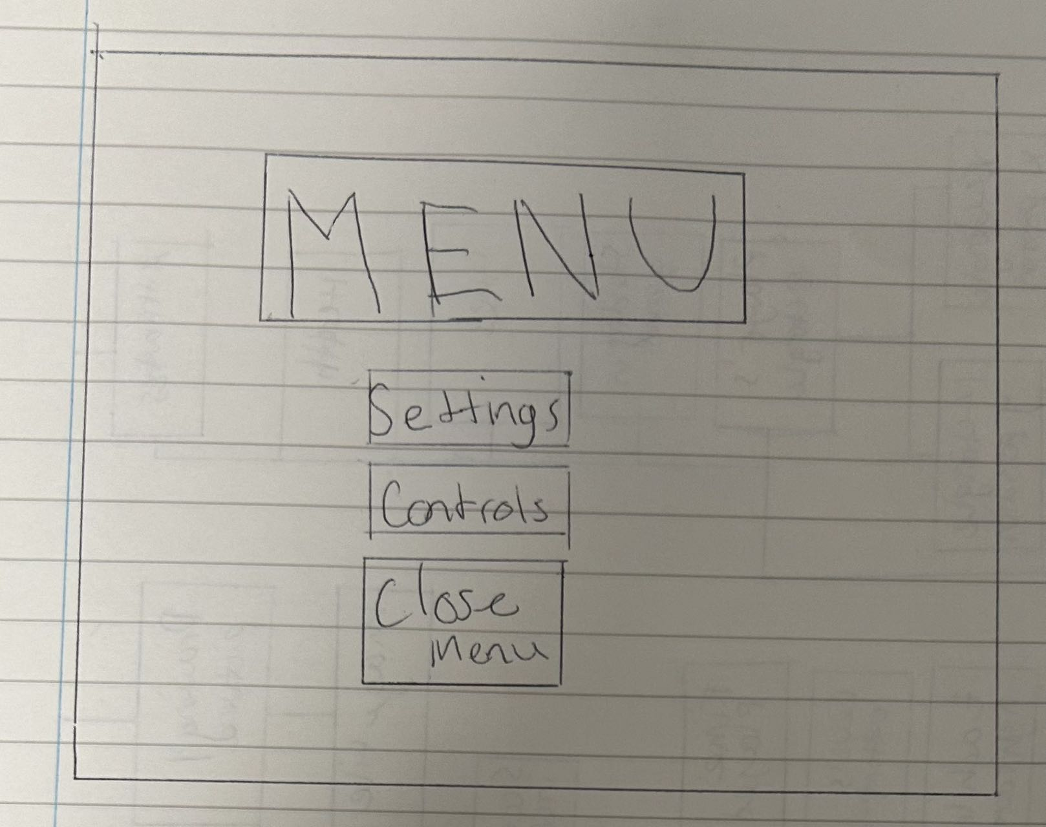

Button to open settings

Everything is placed near the centre so the player’s attention is drawn to the important bits

Button to view list of controls along with their descriptions

Buton to close menu in case player doesn’t know the keyboard shortcut to close menu

Button to close settings if player doesn’t know the keyboard shortcut to do so

Settings title

Screen drawn on top of menu screen to give illusion of a settings menu having been opened

Example setting options that the player can change by an integer value input

Drop down setting options may make it easier for players to adjust certain settings

Input boxes that allow for change of settings

Being able to scroll down the settings allows for more setting options to be added without sacrificing the font size of each option so the player can adjust many settings as well as read them easier without needing to zoom in or look closely

Control descriptions and controls take up the majority of the screen so that as many of them can be fit onto the screen and also draws the player’s attention so they can easily see what the controls are

Similar to settings sub menu, a background is again drawn onto the current screen overlapping the menu screen to show controls section

Ability to scroll down allows more controls to be added, if there will be that many controls

Closes controls menu in case the player doesn’t know the keyboard shortcut to close it

Announcing to the player in capital letters places emphasis so the player knows they won

Menu button

Buttons that provide the player a direction on what to do now that they have finished the level they are on or the game. If game is completed the “next level” button won’t appear

Placeholder, but a drawing that emphasises a win will help improve the atmosphere to make it feel more accomplishing

All that is on the loss screen will be essentially identical to the win screen to provide the same magnitude of effect, but the opposite way

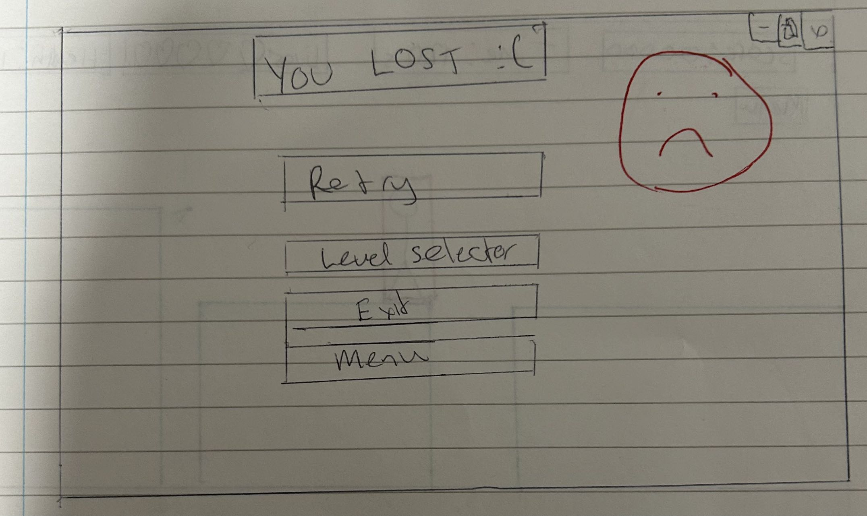

There is no “next level” button as the player has not beaten the current level. (if this level was beaten previously, maybe it could be an exception to let “next level button to exist on this loss screen as well)

Game title in a special font and capitalised so the player knows what game they are playing and that they are in the main menu screen

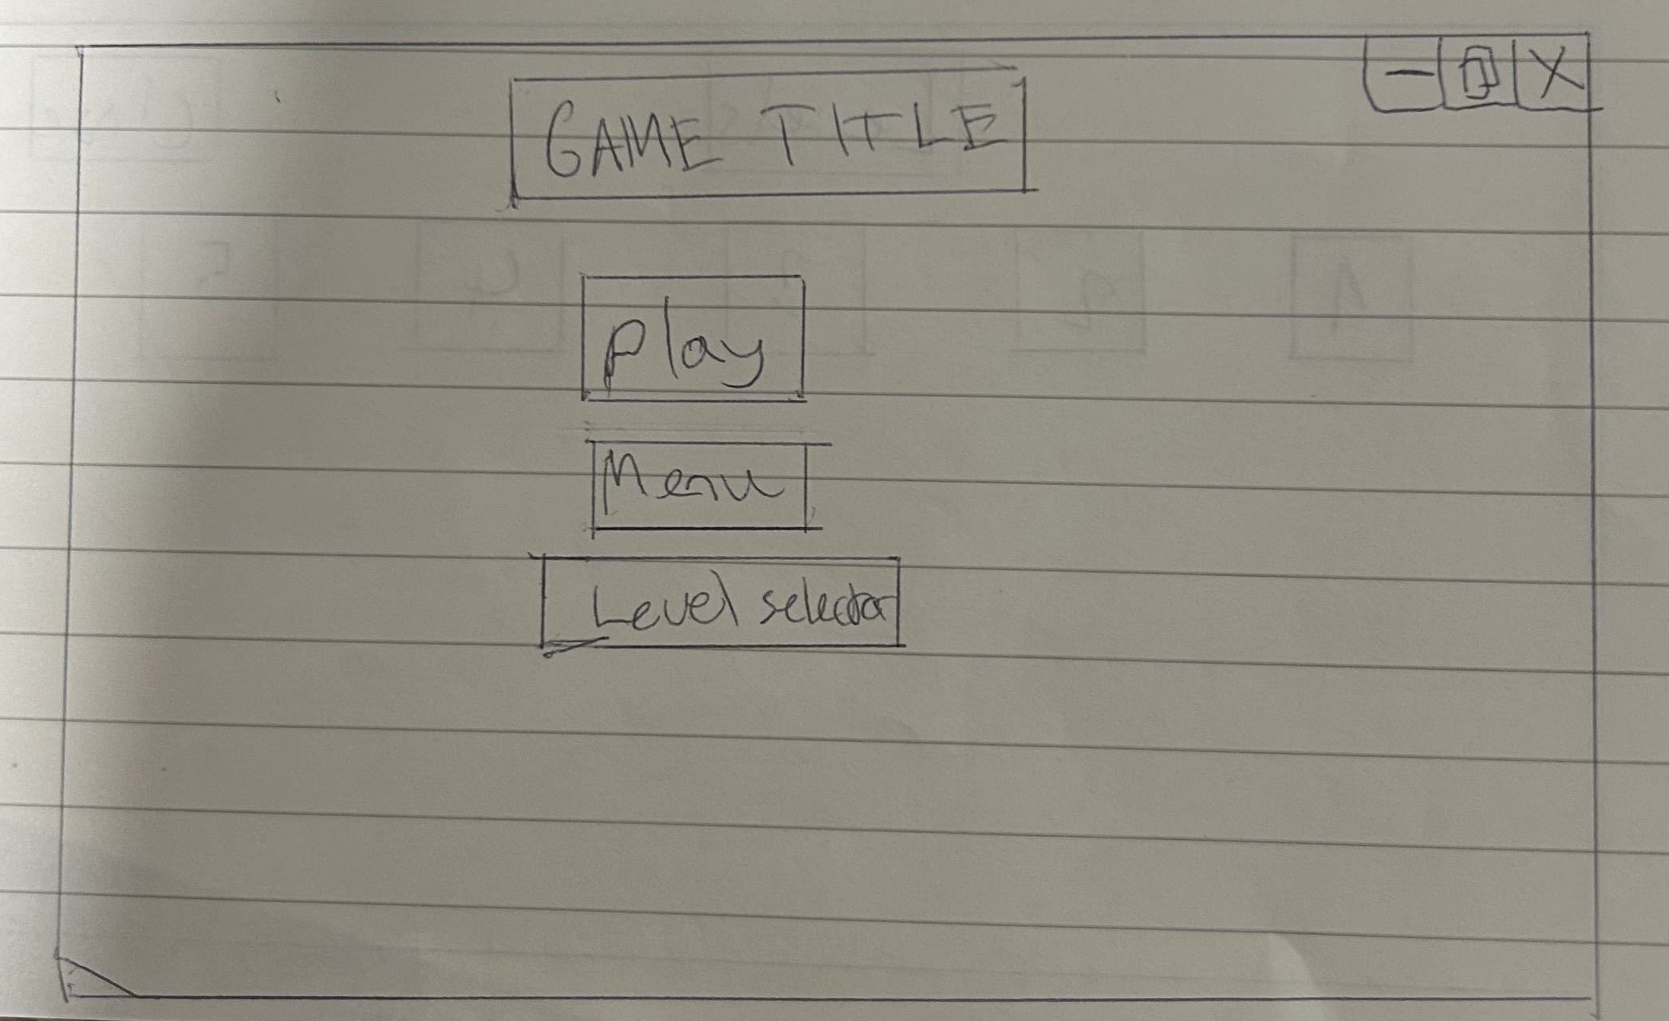

Like with most of the other menu screens, buttons are in the centre to draw player’s attention so they know what choices they can do in the game (play from beginning or go to menu or select which level to play from)

## 

A small rectangle or screen drawn onto the main screen as an inventory, this enables the player to see the timer and other stats of the player while they are accessing the inventory. I am going to implement it like this because when the player is accessing the inventory, unlike accessing the menu (menu state), the player is still playing the game (game state), so completely covering up the rest of the game would be unnecessary and also unreasonable as the player may want to see how much score or time he has. For example, he might need to see his health, then decide what type of item in his inventory he needs to use.

Title indicates clearly to player they are in inventory

Player might have many items and not all of them can be viewed within the small screen, scrolling will enable them to have more items

Placeholder / example grid, items /collectibles will be stored in these slots, player can press on a slot to access / use the item

All these statistics and attributes are at the top of the screen (maybe to the side) because they important so they need to be seen by player, but also don’t need to be blocking the player’s field of view

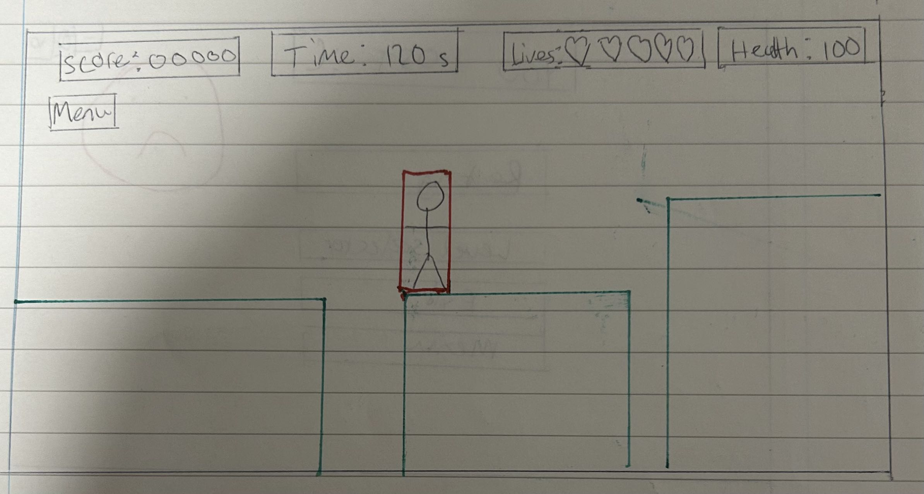

Player’s image

Menu button to access menu in case player doesn’t know the keyboard shortcut to open menu

Player’s rectangle which is their hitbox and used to detect collisions

Level selector menu, again, like all other menus the title is in the centre near the top to draw the player’s attention and tell them clearly where they are in the game

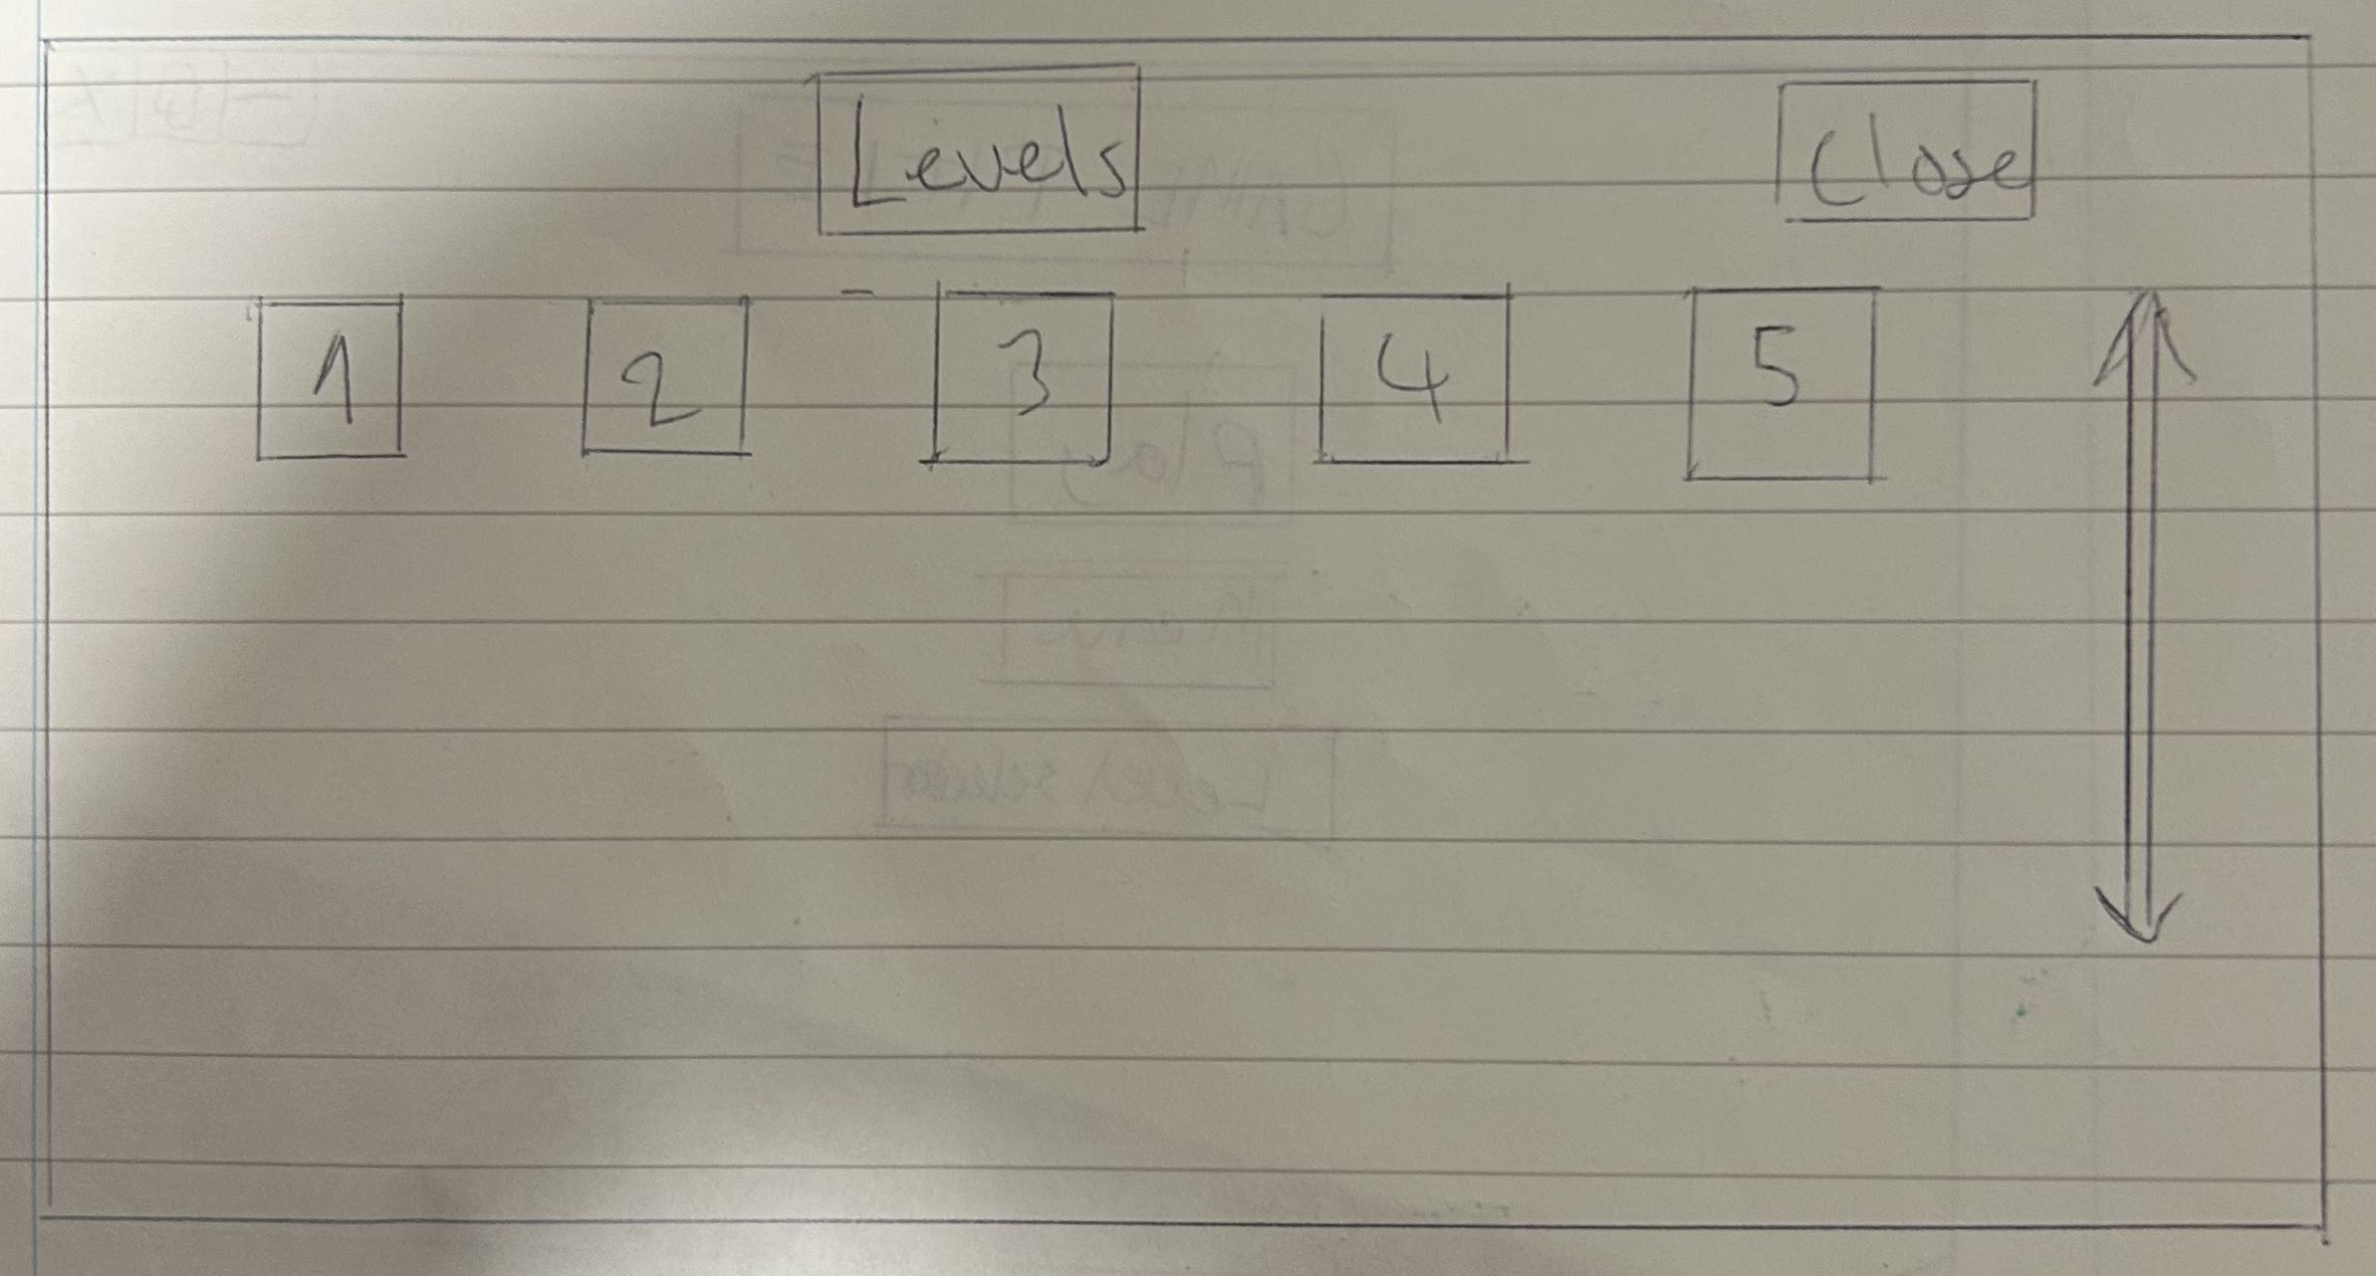

Buttons that allow the player to access the corresponding level on click

If there are a lot of levels that cant fit on the screen, scroller will be placed here to indicate to the player they can scroll down in this menu to see more existing levels

## Classes

In order to keep my game organised, I will make my classes in a separate file from my main game, and import it as a module to be used in my main game. This way when trying to make additions to the game, such as levels, I can very easily make the levels simply by just creating instances of a class and then putting them into a level’s group then draw them in.

Starting off with making the levels, I will need obstacles, therefore breaking down the obstacles I will have, I will need:

* Moving obstacles
* Static obstacles
* Obstacles that deal damage (Killblock)
* Block that is a win condition (touching it beats / completes the level)

I am choosing to make separate classes for each obstacle because this significantly simplifies building the game’s levels when I come to that part. This is because by making the obstacles classes, every time I want to add a platform to a level, I can go to the level’s code, create a new instance of the type of platform, then add it to that level’s group of objects. This will help save time as I am essentially making myself a map builder. If there is a bug with a type of platform, it also makes it easier for me to debug as all the code is centralised in one spot, underneath the class’s definition.

Moving obstacles class diagram:

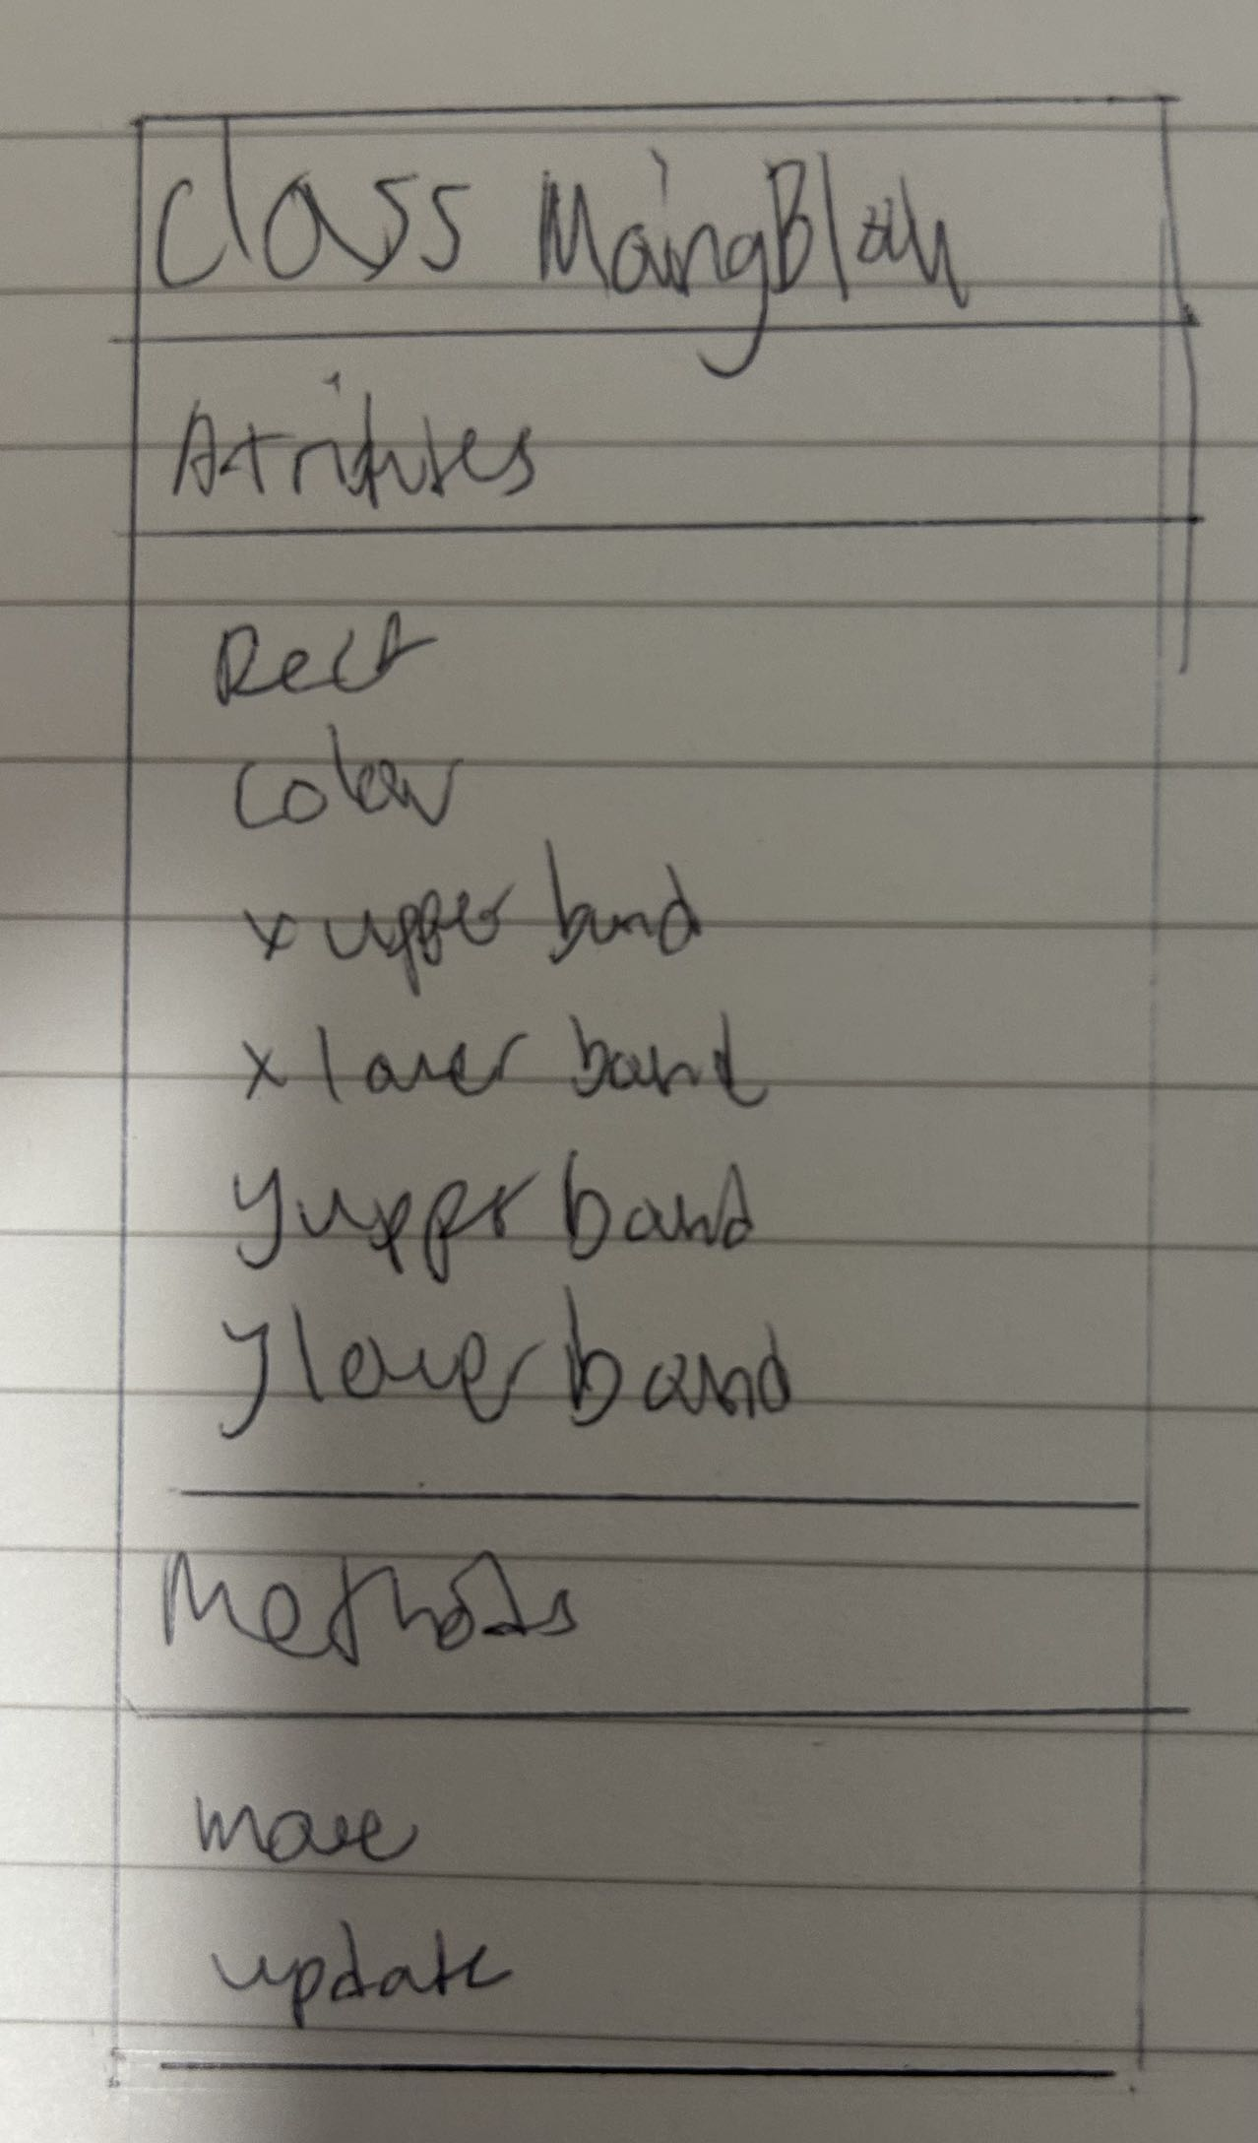

Static obstacles class diagram:

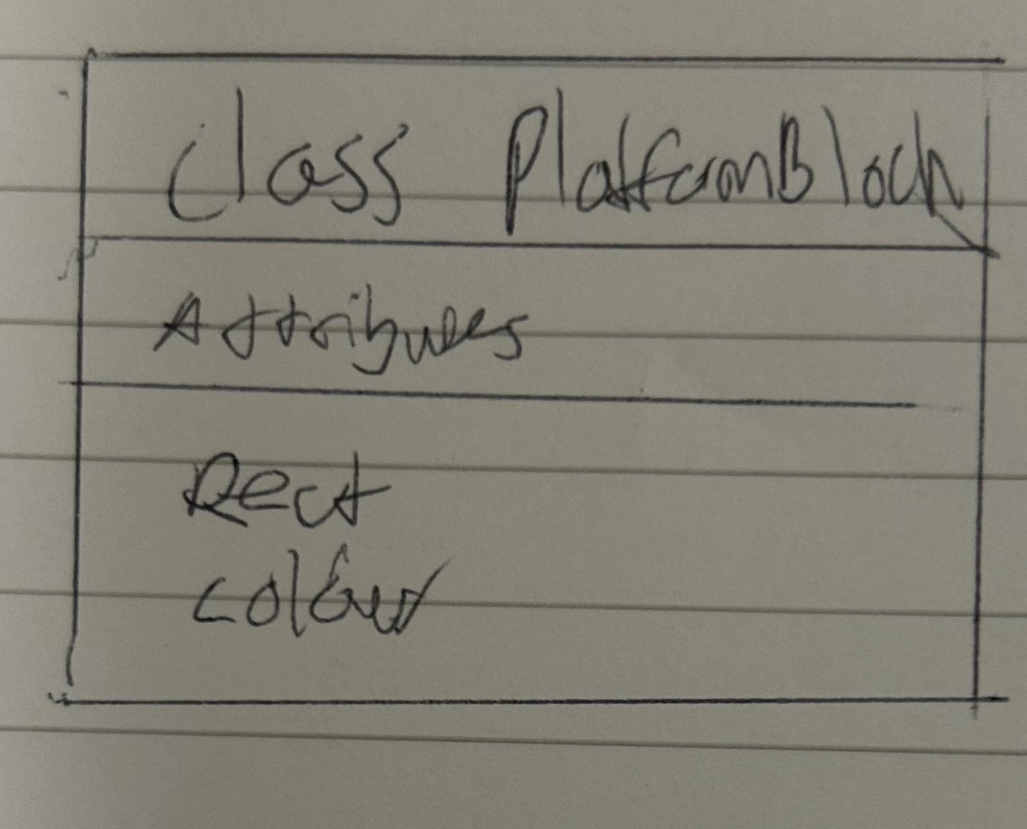

Killblock class diagram:

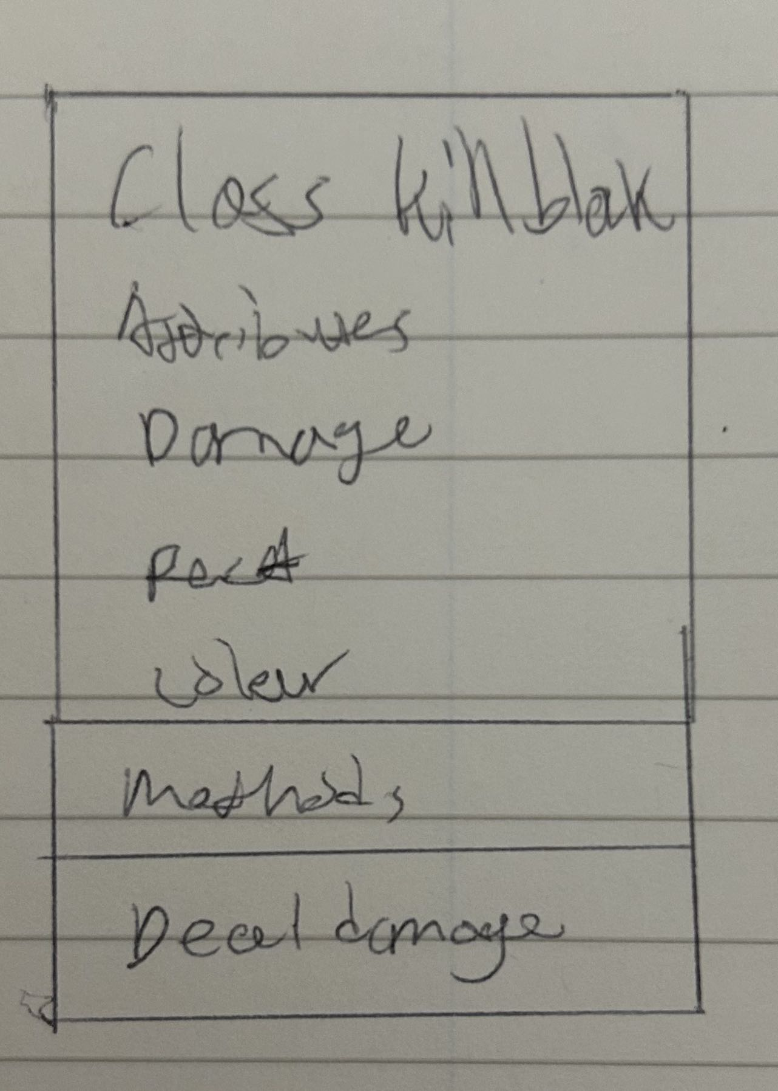

Win condition class diagram:

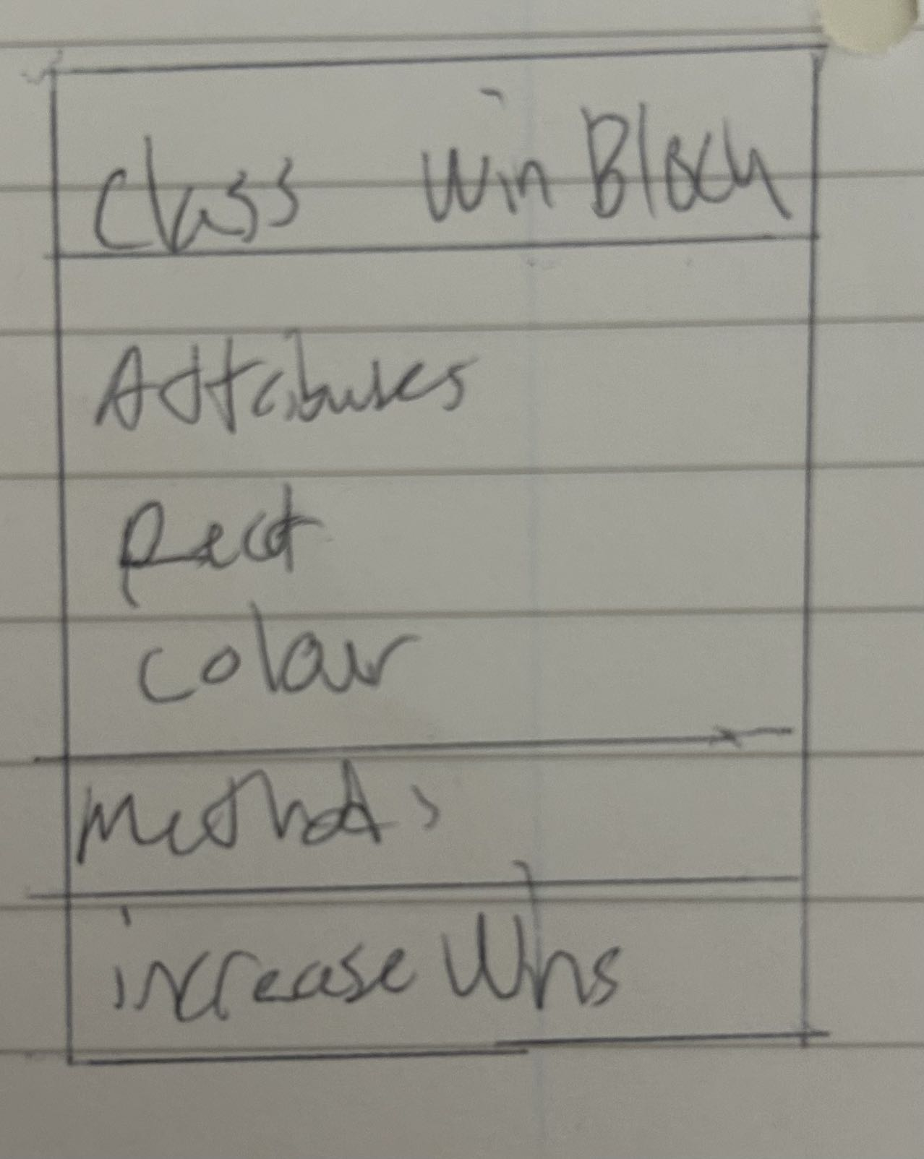

Another class I plan to use is for the player’s character. It will include all the player’s attributes (via constructor) and features (via methods). This makes drawing the player into the game easy as just like the obstacles, I create an instance of the player class and simply draw them in.

Player class diagram:

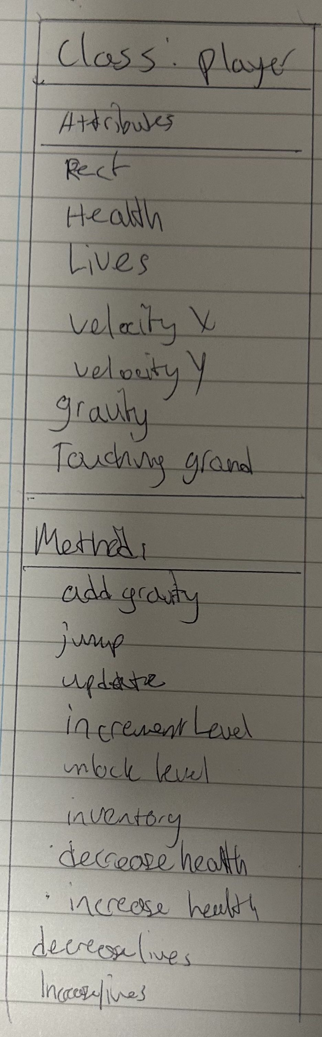

As I will be making multiple screen such as menus and settings, I will need buttons that the player can click to interact with the screens. Therefore I will make a class for buttons as well so that every time I need to add a button I can do so quickly and efficiently.

Button class diagram:

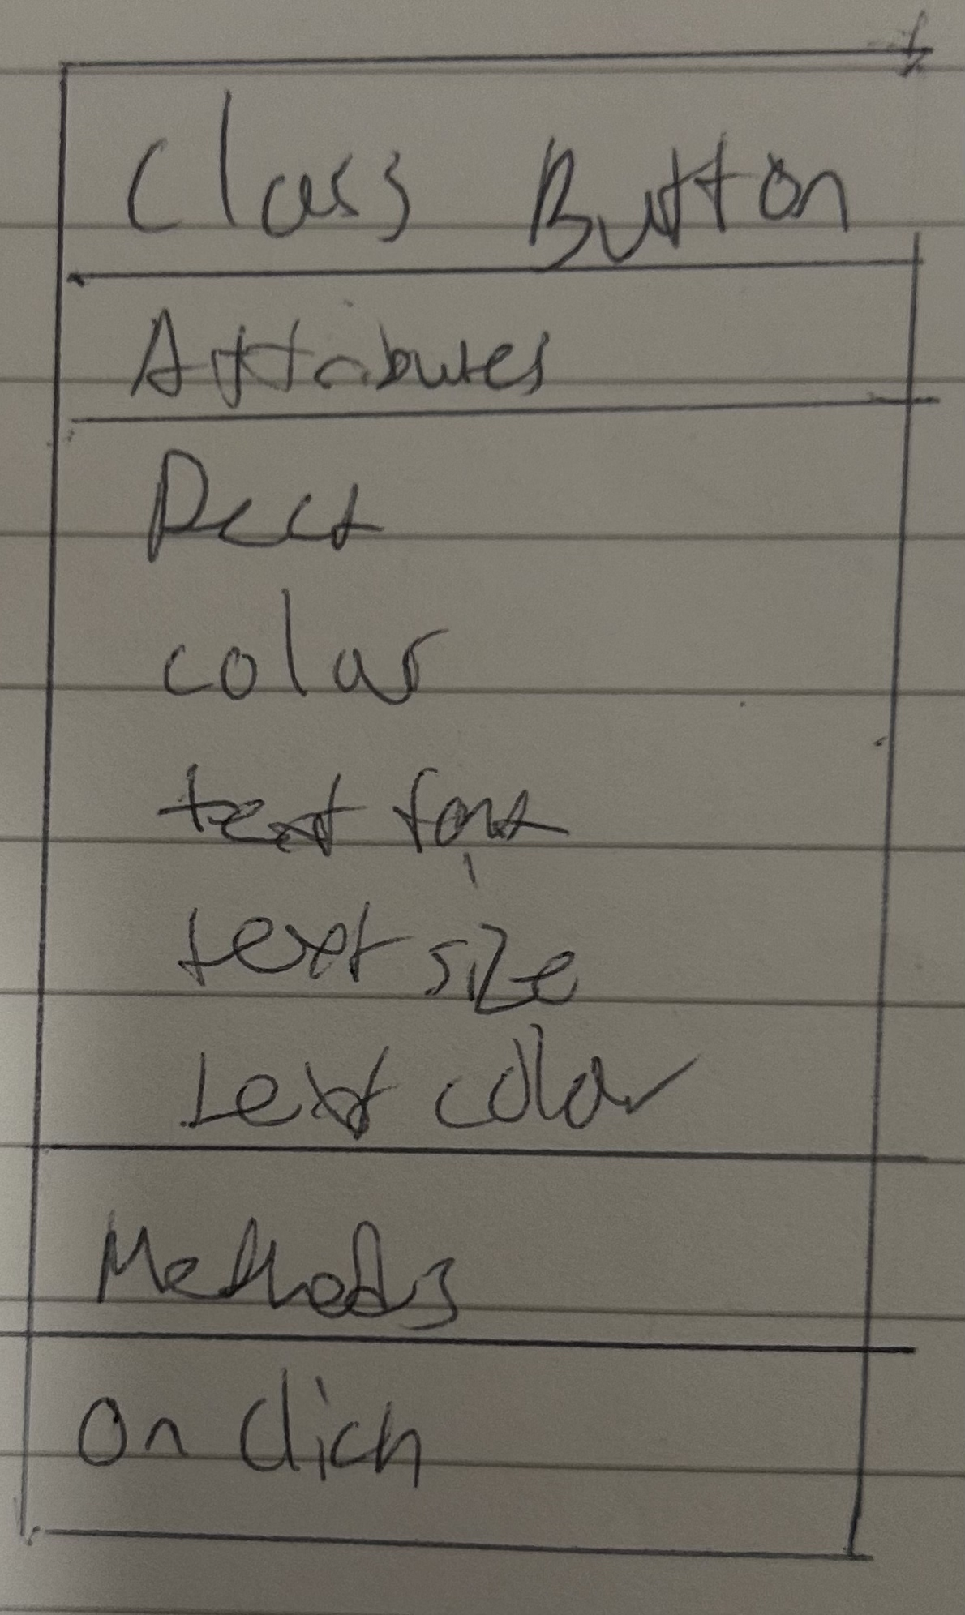

# Algorithms

Below I will show all the algorithms that I am sure on how I can implement into the game.

Base movement algorithms:

* Moving to the left
* Moving to the right
* Jumping
* Falling

Settings options:

* Adjusting volume
* Adjusting display size

Camera:

* Horizontal camera scroll
* Vertical camera scroll

Level selection menu

Game on startup

Main menu

Collisions:

* Horizontal collisions
* Vertical collisions

Moving right:

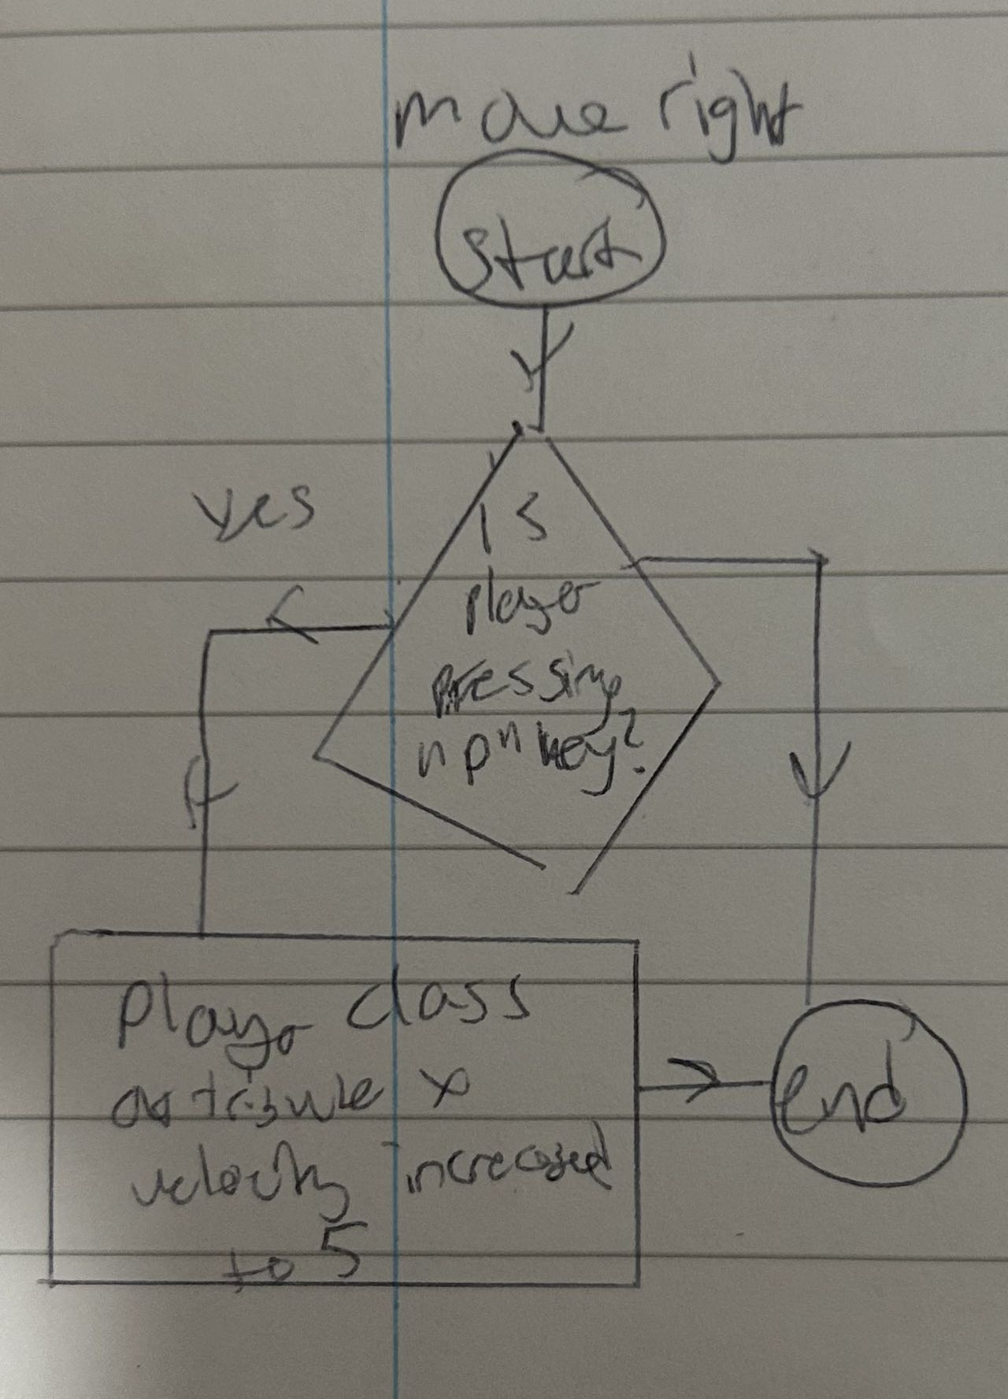

Moving left:

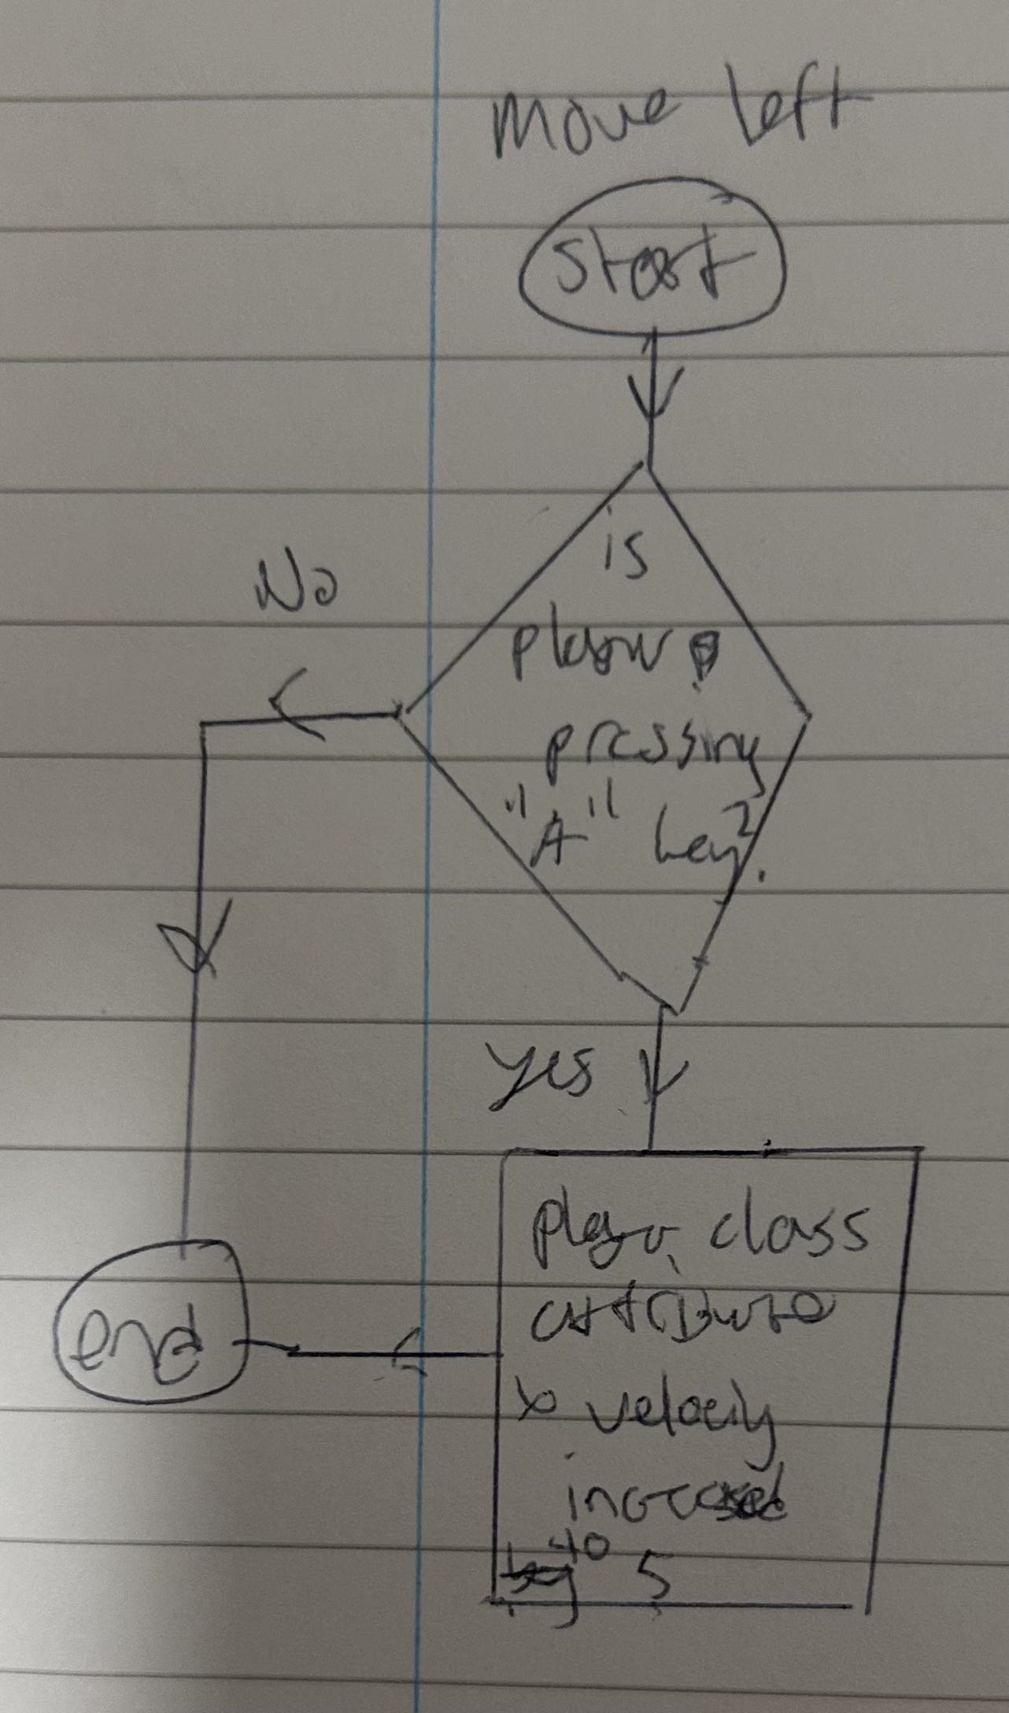

Jumping:

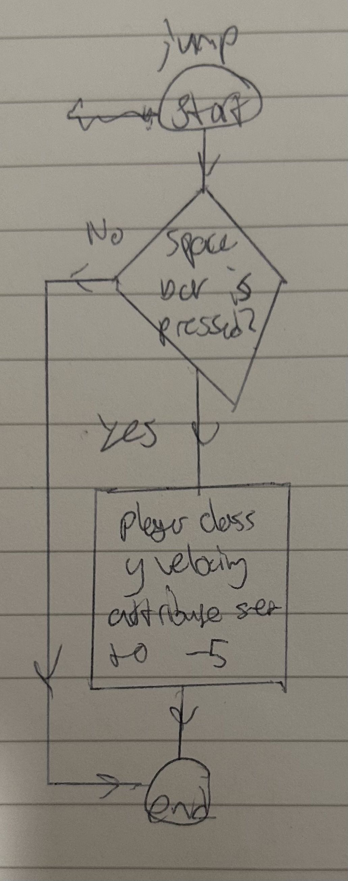

Falling / gravity being added on:

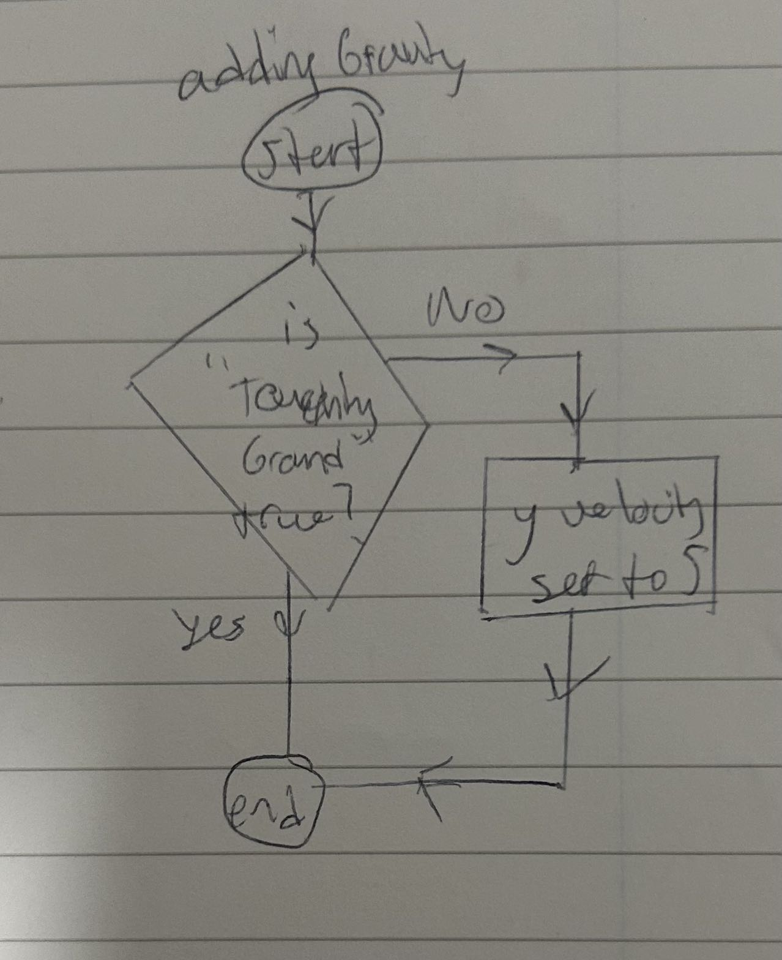

Collisions:

Horizontal collisions:

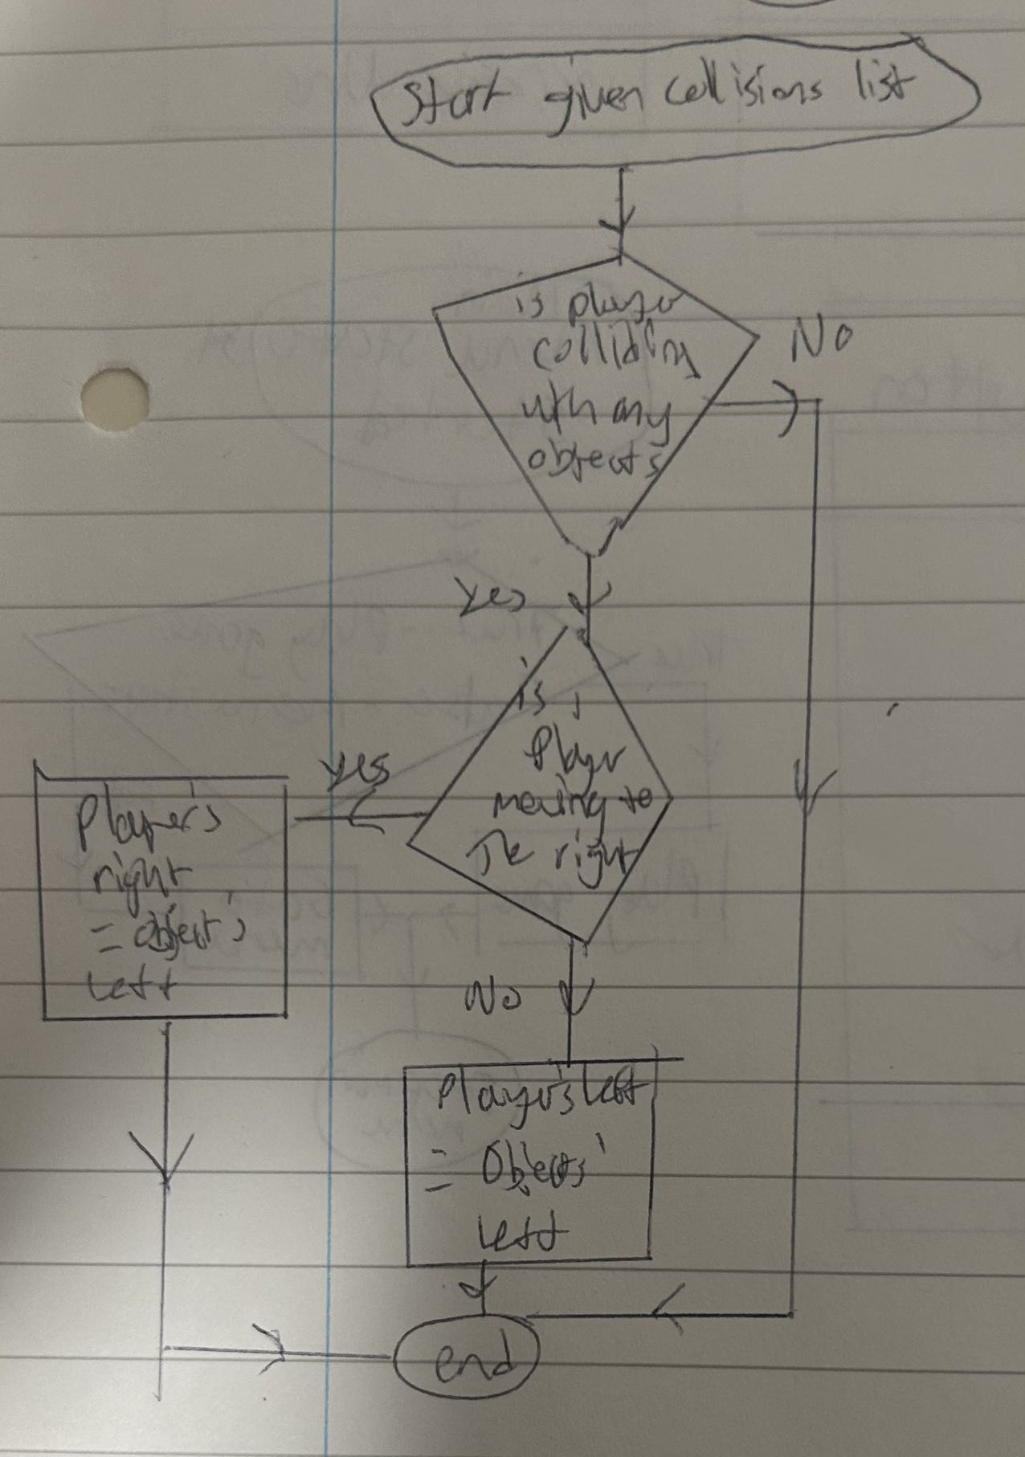

Vertical collisions:

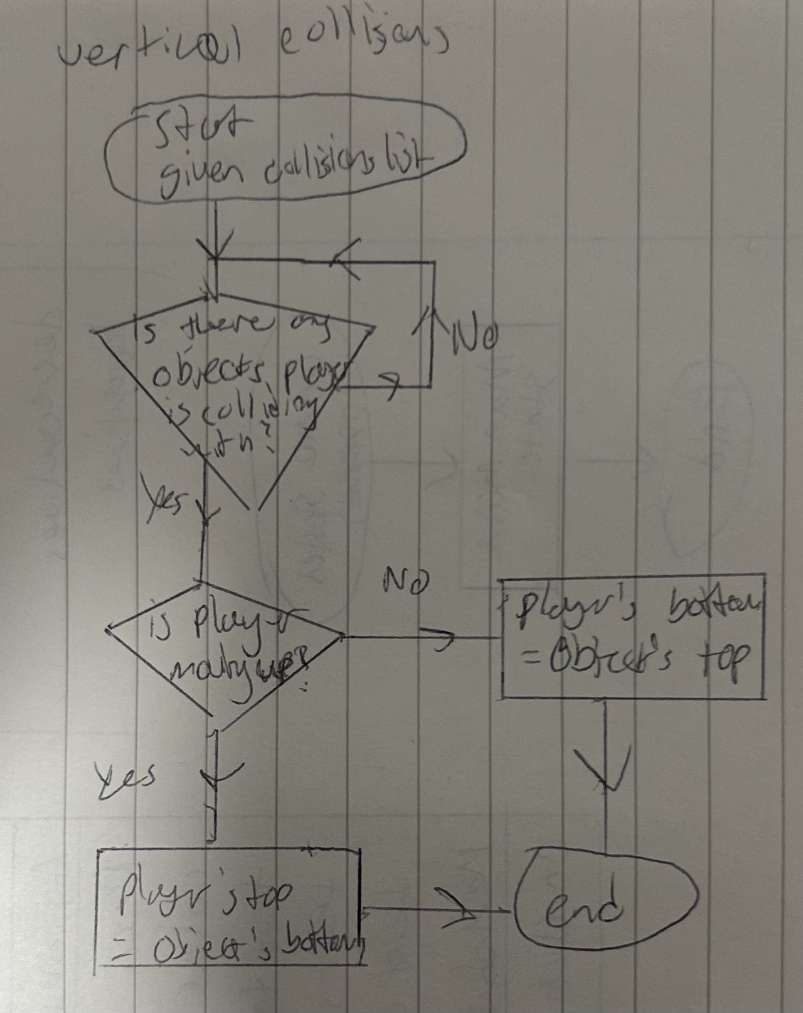

Camera scrolling :

Horizontal scrolling :

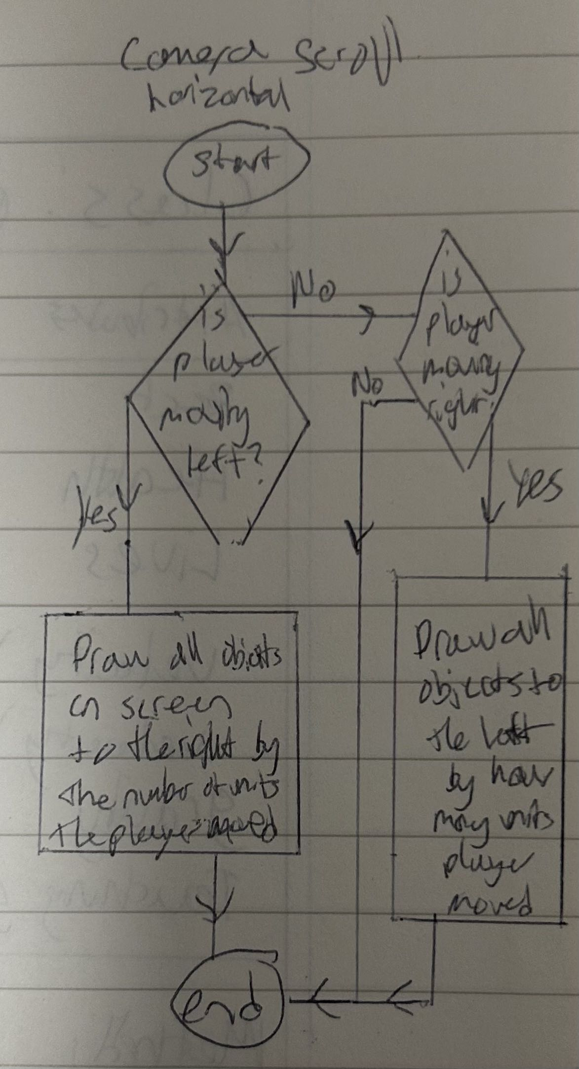

Vertical scrolling :

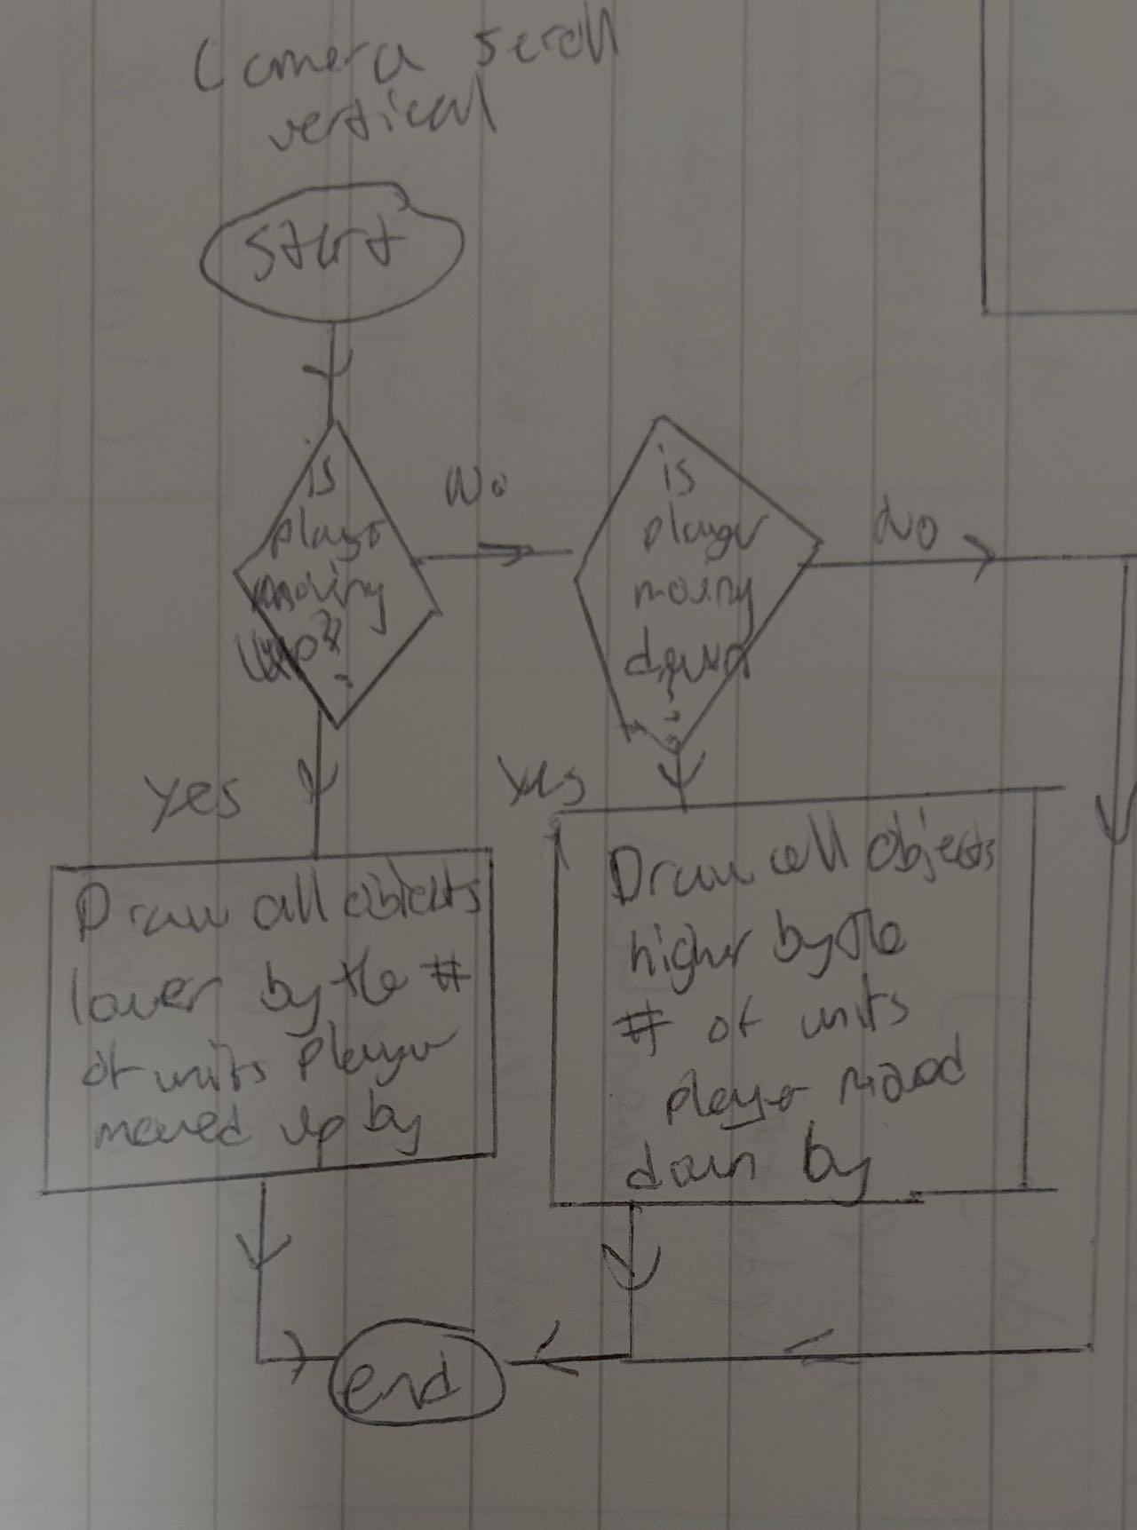

Game upon being opened:

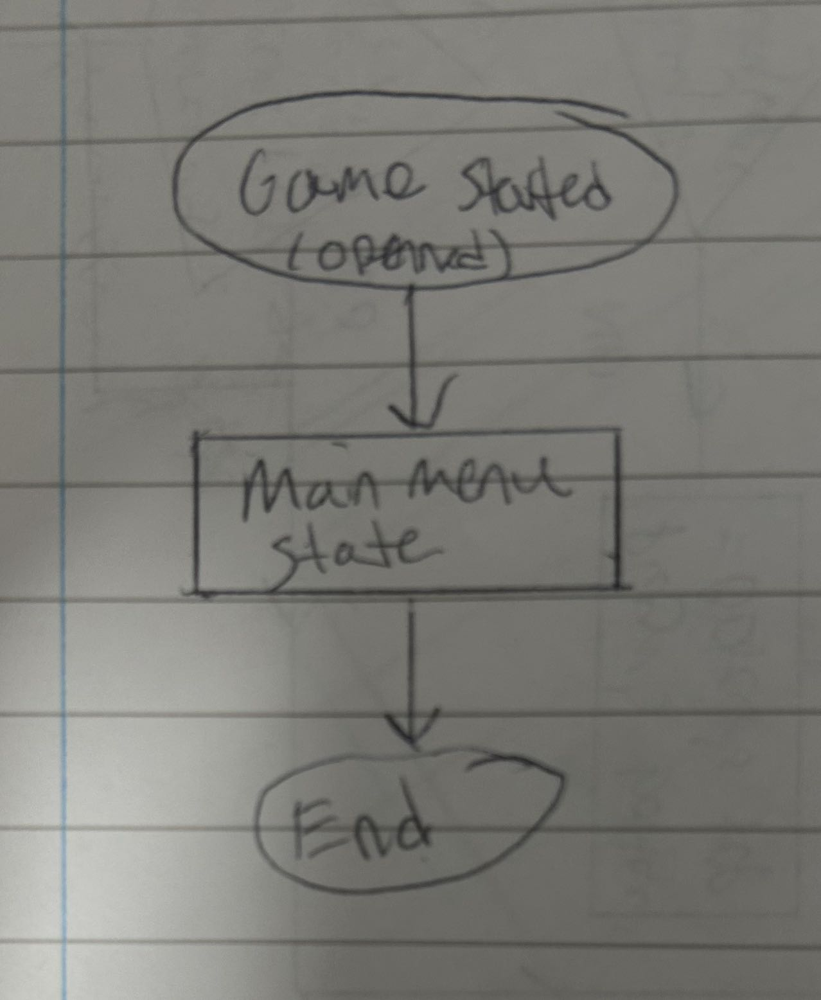

Main menu state :

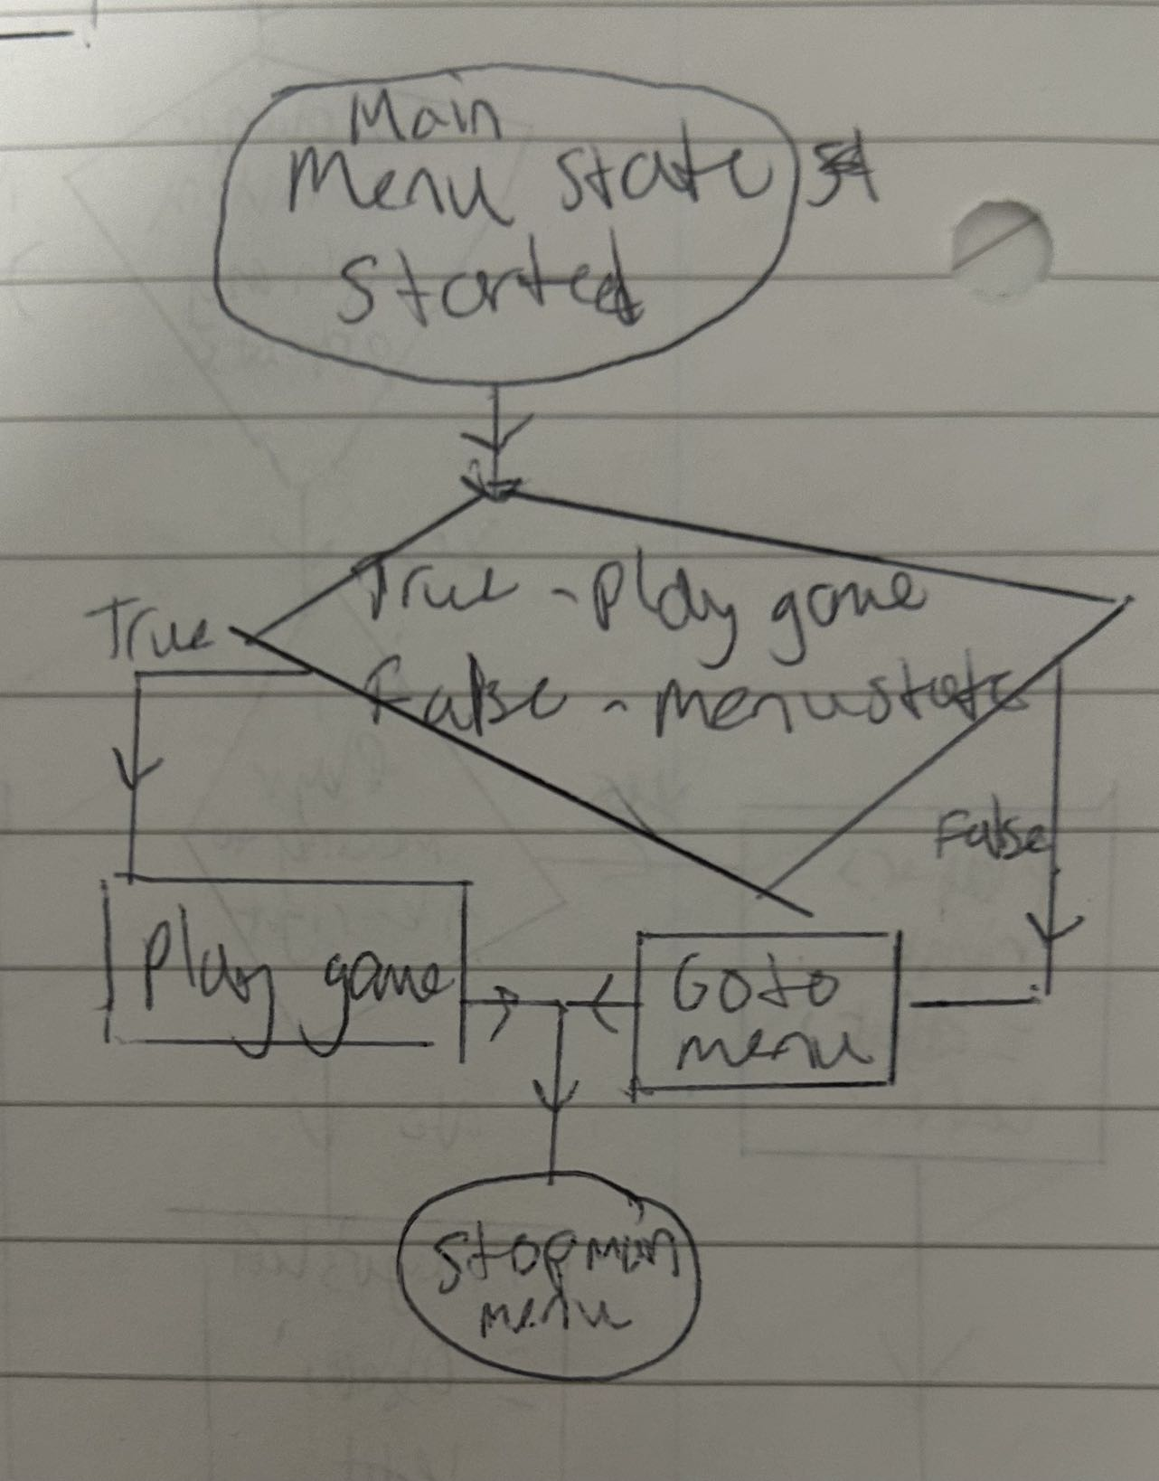

Settings option for volume :

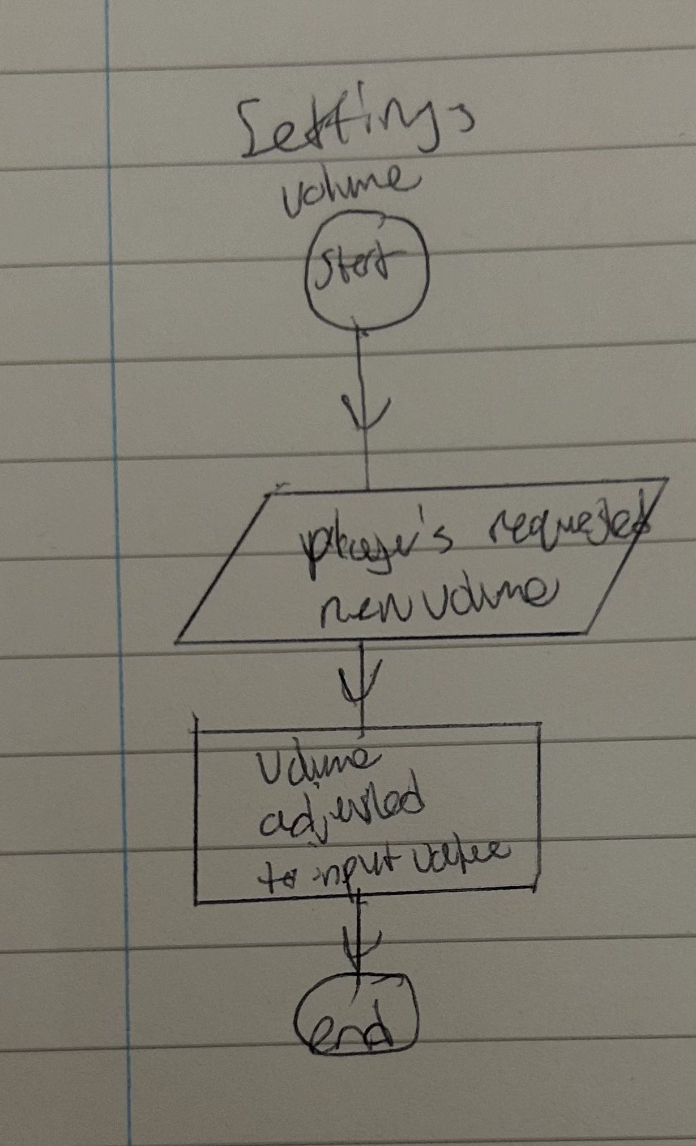

Settings for display resolution:

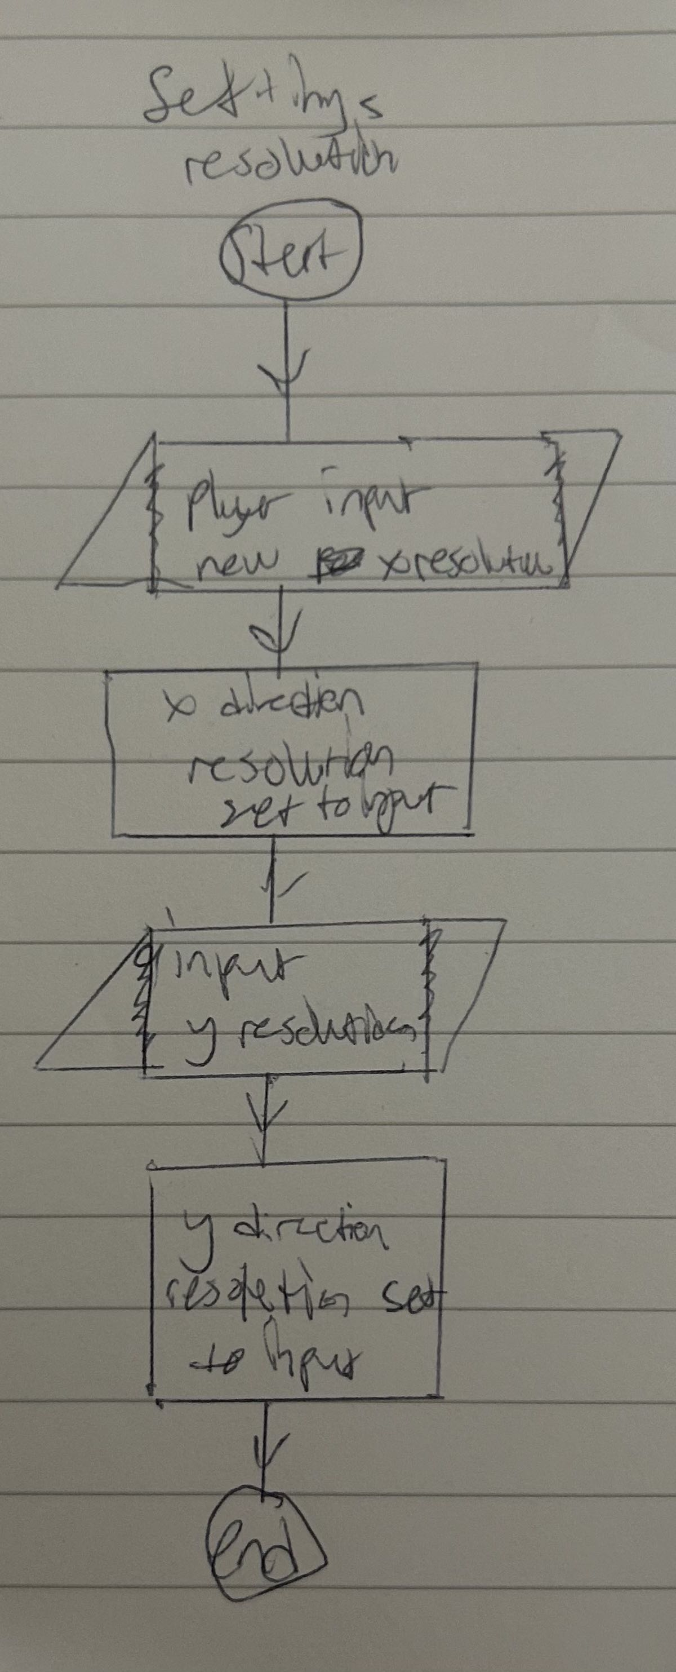

Level selection menu:

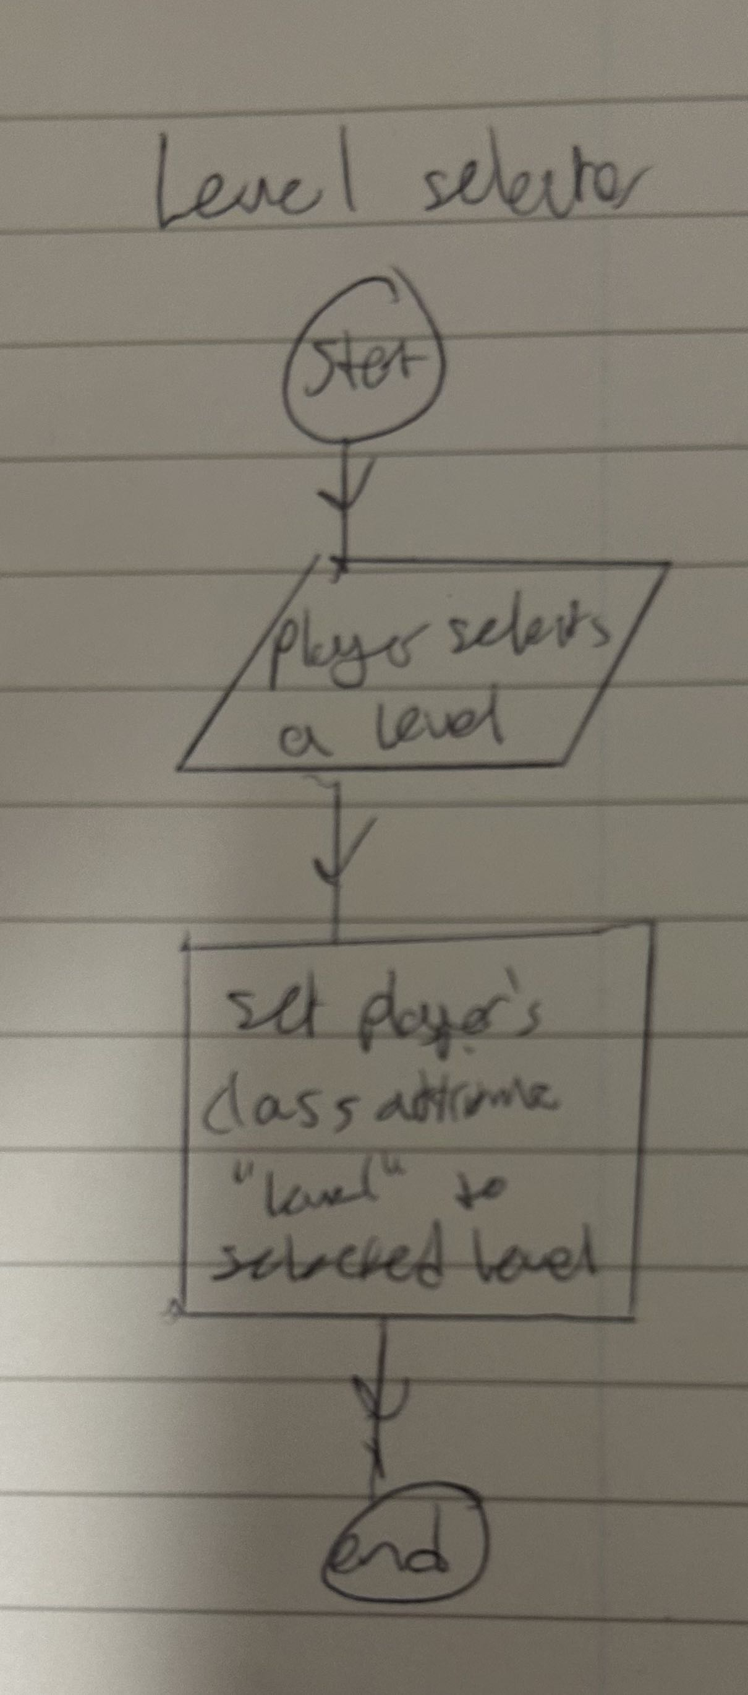

## Main variables and data structures

Here I will list all the key variables and data structures that I plan to and know will definitely be in the game during implementation.

|  |  |  |  |  |
| --- | --- | --- | --- | --- |
| Classification | name | Data type | Function | Justification |
| Variable | size | list | This variable is used to tell the program how large to draw the game screen | I need this variable because of the settings feature I will add, which if the player choses to change the resolution, then when they do so, this variable’s values will be changed so that the screen can be drawn to the size of their liking |
| Procedure | play | - | This procedure will run and load in the game, so after the player has pressed play in the main menu, this procedure starts and begins drawing in the game | I have a procedure for playing the game because I will have different game states such as when the player is in the menu or in the settings. This procedure ensures that the game only runs when the player is actually trying to play the game |
| Procedure | mainmenu | - | This draws on the main menu onto the player’s screen. This is run as soon as the game is opened. | This like the procedure above isolates the game states making it also easier to work on different parts of the game. Also when the game starts to be played, it allows the game to stop running this procedure and run the play procedure instead to play the game, effectively stopping the main menu from appearing while playing. |
| Variable | cameraXoffset | Real | This variable is subtracted from all objects in the game’s x positions, so that the entire map is drawn such that the player is in the centre, producing the illusion of a camera like effect whenever the player moves | This is needed because without a camera, the player would only be able to see a limited part of the entire map, as their screen will only capture as much as their display resolution. Using this variable in junction with the below one creates an effect of a camera, this allows me to add many platforms and make larger level designs and more complex ones for the player. |
| Variable | cameraYoffset | Real | Subtracted from all objects in the game’s y position so that entire map is drawn relative to the player’s y position. Part of the above variable to create a camera that follows the player. | Reason directly above^ |
| Variable | Collisionslist | List | This is a list that holds all the sprites that the player’s character collides with. | This list is needed as it will be searched into for objects that have collided with the player. This can then be used to work out both horizontal and vertical collisions. Without collisions, the game wouldn’t be a platformer as you would just fall or walk through platforms |
| Game state | Main menu | - | The screen that is seen when the game is opened | This is where the code that defines the main menu will be written in the main game file (maintains organisation of code) |
| Game state | Playing | - | The actual game itself | The code for the main game will be under this section in the main game file |
| Game state | Settings | - | Settings sub menu that allows player to adjust parts of the game | The code for settings will be under this section in the main game file |
| Game state | Level selector | - | This part allows players to select what level they want to play on | This also maintains organisation of code by keeping blocks of code that are on level selection under this section |
| Procedure | Settingsopen | - | opens up the settings menu so the player can adjust things | All code that gives the settings functionality will be in here. Allows the settings to be easily opened or closed. |
| procedure | Levelselector | - | Opens up the menu that lets the player select a level | Code that manages the level selection menu is kept here, this allows this sub menu to easily be opened or closed. |
| Variable | Done | Boolean | Determines if the player has finished playing the game and closed it or not | This variable is checked every cycle so that the code can close the game if the player has chosen to quit it |
| Variable | Player | Instance | The player’s character in game | Used to dra w the player into the game, this allows the user to see their character and what they are doing in game. |
| Module | Colours | - | Contains all the colours for drawing I may need | allows me to easily access colours I want to use for drawing purposes in all my files. My levels will be in separate files so it saves me time from having to redefine every colour I may need to use in every single level file. |
| Module | Classes | - | Contains all the classes to be used in game | I have this as it keeps my project organised, writing all the classes separately in this file allows me to more easily identify future bugs and errors. Also because my levels are drawn in separate files, they each need to access the classes for the platform types, so it saves time as I don’t need to redefine each class in each level file. |

## 

## Test Data

Movement controls:

|  |  |
| --- | --- |
| Test data | Validation |
| “a” | Valid |
| “d” | Valid |
| “e” | Invalid |
| “f” | Invalid |
| Spacebar | Valid |
| “s” | Invalid |
| 9 | Invalid |
| [ | Invalid |

Open menu:

|  |  |
| --- | --- |
| Test data | Validation |
| “m” | Valid |
| Click on menu button | Valid |
| Click not on menu button | Invalid |
| “p” | Invalid |
| Click on edge of menu button | Boundary but valid |

Open settings:

|  |  |
| --- | --- |
| Test data | Validation |
| “n” | Valid |
| “l” | Invalid |
| Press on settings button in menu | Valid |
| Press on edge of settings button in menu | Boundary but valid |
| Press not on settings button in menu | Invalid |

Score board:

|  |  |
| --- | --- |
| Test data | Validation |
| Updated score < 0 | Invalid |
| Updated score > 0 | Valid |
| Updated score = 0 | Boundary but valid |
| Updated score is an integer | Valid |
| Updated score is not of integer data type | Invalid |

Open level selector:

|  |  |
| --- | --- |
| Test data | Validation |
| Press on level selection button in menu | Valid |
| Press on settings button in menu | Invalid |
| “e” | Invalid |
| “l” | Valid |
| “,” | Invalid |
| 2 | Invalid |

## Required results from testing

# Implementation Stage

## Stage 1

In this stage, I will start off by making the base mechanics of the game. This includes:

* Basic movement controls (w, a, s, d, spacebar, etc)
* Collisions
* World side scrolling camera on movement
  + Player is centre locked
  + When moving in a direction, the objects on screen are moved relative to the player’s movement, if a boundary Is nearby, and the player moves toward boundary, the camera doesn’t exceed the boundary.
* Some game states including:
  + Menu on startup
  + Settings button + settings
  + Quit button that ends the game
* Respawning + live/health system
* Dynamic obstacles

Character creation:

I started this off by making a separate file that I will import as a module because by keeping all classes in one file, it keeps my overall code organised and easy to manage.

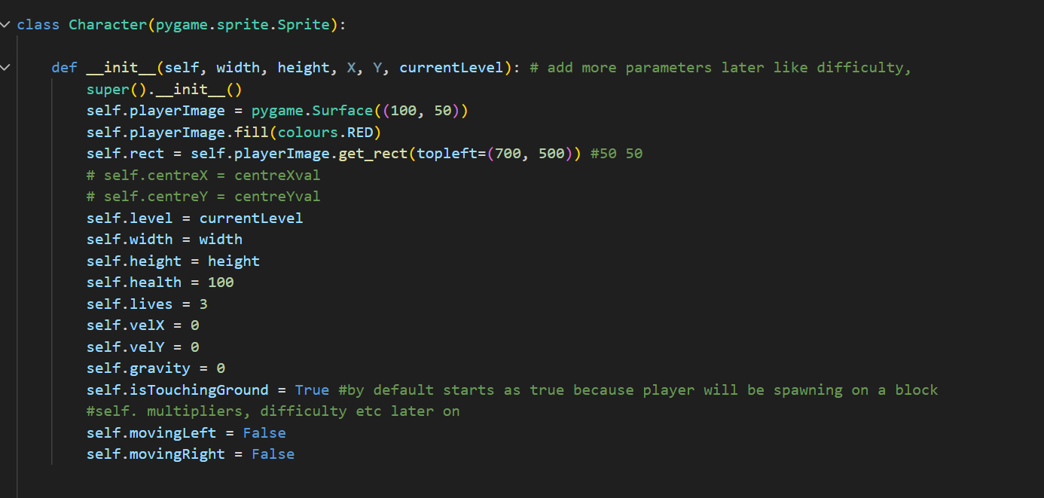

First of all I define the variable I know I am going to need for sure. This makes programming the character’s functionality easier.

My first error with this is when I initially tried to draw the player on to the screen. I did this initially by just using the pygame’s feature of drawing a rectangle. The issue with this is that this rectangle was separate from the actual rectangle that was controlling the player’s behaviour, i.e the hitbox for collisions.I fixed this by using the blit() method because this draws on the rectangle I made in the attributes of the initialisation.



Bug with collisions

While making the collisions for each platform my player can interact with, like standing on, going into, I ran into an error that caused my player to either do one of the two: horizontal collisions work but vertical don’t so for example standing on top of a block, when I move I get teleported to the side, or vice versa where ifI try to go into the side of a block, I phase right through it. This is because horizontal and vertical collisions need to be handled separately, and with up to date information on the player’s position. By separating them, this prevents the two collision detections from overlapping with each other. And also ensures that the position of the player used to calculate and detect collisions is up to date and doesn’t cause issues. This can be done by redefining the group of objects my player collides with after each directional collision check, and I separated the two collision checks by just running the horizontal checks first, then the vertical.

Before:

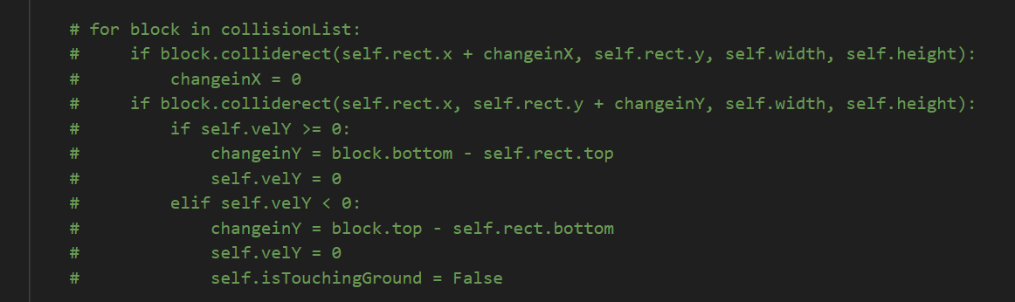

^ The collisions are all done in the same loop so the bug occurs

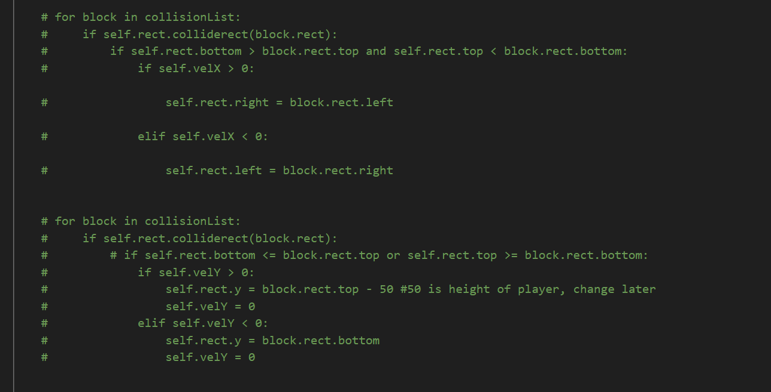

After: 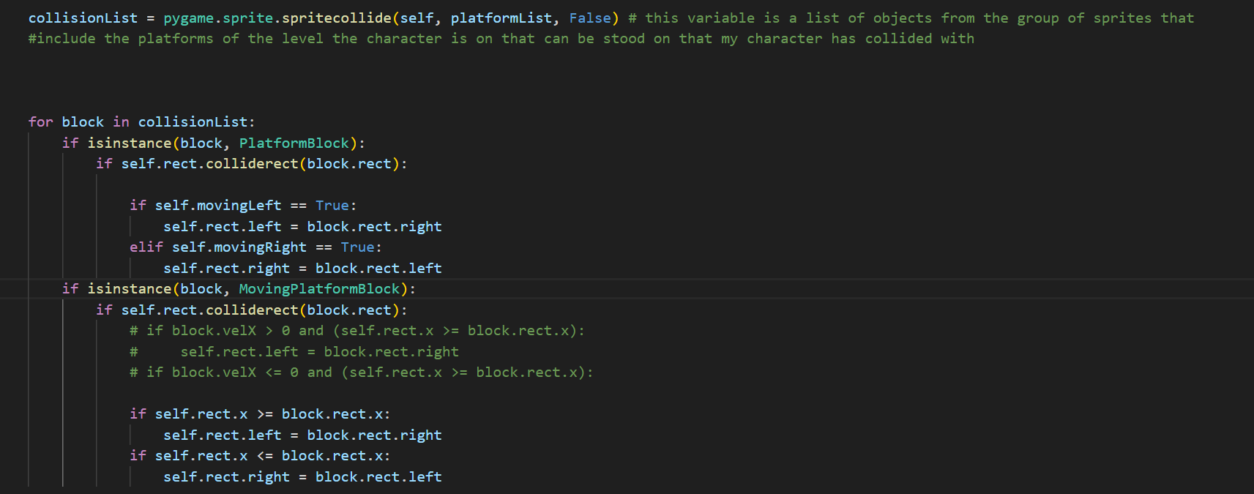

Horizontal checks ^

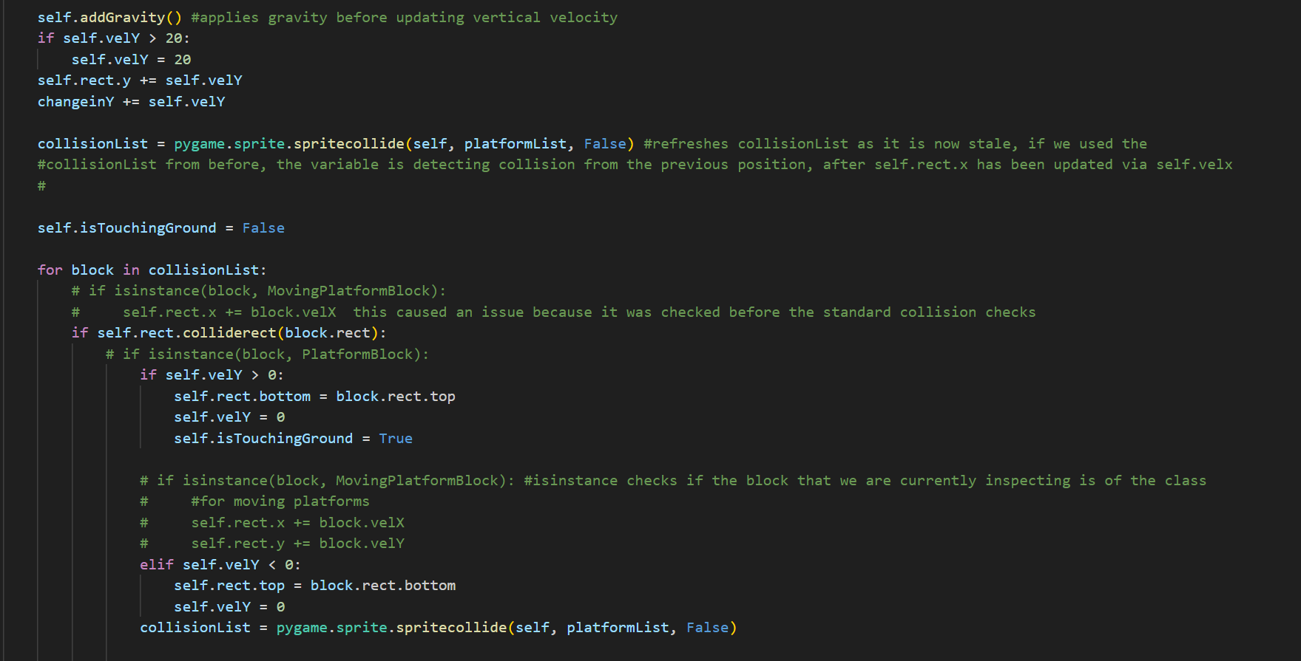

Vertical checks ^ done entirely in a separate loop

Bug with importing modules (circular import):

While first trying to understand how to use modules, I made the mistake of importing a module into another one, and vice versa at the same time. This results in something called a circular import. What this means is that because when you import something, it first runs everything in in the module that was imported, it means you cannot use anything from the file you have imported into before the module that was imported because the code would not have been run yet. So for example in my main game file I used something from the module I imported from, but in that module I imported the main game, meaning since the main game has something that uses my module, and then it has been imported into the module, since somethings may have not yet been defined during run time, then we have an error because the code does not know what the undefined variables or functions are.

In classes file:

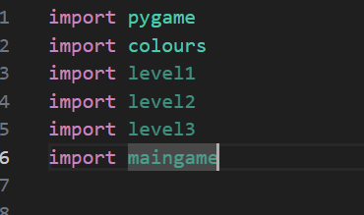

In main game file:

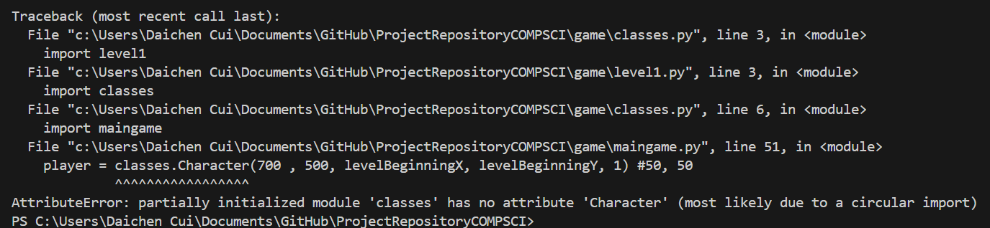

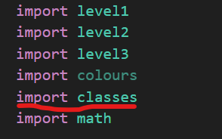

Gravity error:

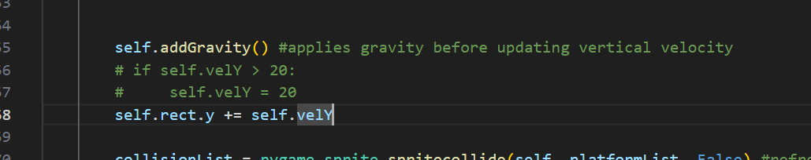

This piece of code in blue shows the original code that was used to calculate gravity. The issue with this is that it makes it so when the player falls, the longer they fall the faster they fall for an indefinite amount of time so there is no terminal velocity. At the time of this code being made there was not yet any boundary conditions that make sure gravity doesn’t drag you down while you are touching ground, because what this would do is that since it continually adds gravity, sometimes it would make jumping not work as the downwards velocity would be so high, and this would also often result in you falling through the ground because eventually your velocity would be so high the game couldn’t store it and the code just breaks.

The part in comments is the solution, by making a limit for how high the downward velocity can be, it acts as a boundary condition. This is also a secondary boundary condition to prevent falling through the ground for later one when I add actual boundary conditions to ensure that I don’t fall through platforms.

Jump implementation / fix:

Making the jump mechanic simply requires a quick input detection, then just changing the vertical velocity to decrease (as in pygame going up means to decrease y position), however the issue with this is that we can jump infinitely and this is unrealistic for the game because it would make it too easy. To prevent this I needed a boundary condition that also happened to prevent the falling through bug prior to this. 

The value chosen for the gravity was picked just from testing what I thought would work, the value is mostly just random.

Moving block collisions / velocity bug:

Initially I thought of making an entire separate method that detects for collisions only if you are in contact with an instance of the class for moving platforms. This however is inefficient as I can just include it into my main update method for the player. By simply adding an extra conditional that needs to be check so the the collision detection code can tell which set of collision checks to use

In horizontal collision loop:

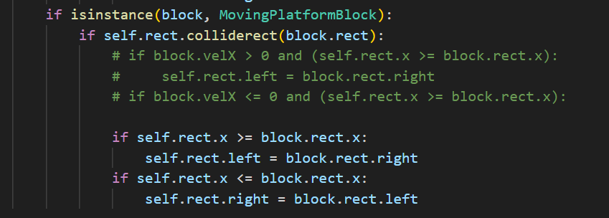

In vertical collision loop:

While doing this, I ran into an error where whenever my player stands on the top of any moving platform, although the game does update my x position, it does so incorrectly as it does it too slowly, meaning it isn’t adding up enough velocity to my player has enough, so I just doubled the rate at which my velocity is updated when on the block to get to the platform and player to update velocity at the same rate.

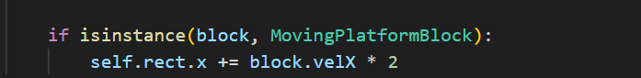

World scroll / moving camera bug:

The first bug I encountered while trying to make a moving camera that follows your player around so I can make larger level designs that exceed the player’s devices’ resolution is when the objects on screen were moving in the opposite direction of the player’s movement (correct bit) at a rate that wasn’t accurate to the actual positions of the objects (error part). Sometimes for example, you would see the player walking on thin air or inside a block and collision not kicking in, this isn’t the issue of the collisions but rather the way everything in the game was drawn. This also made it so the character on screen, the camera would not be following it fast enough and the player could still go off screen. This was due to cameraoffset values having only been applied to platforms and objects. But in reality you have to apply the offset to everything that needs to be drawn otherwise the ones that don’t have a corrected offset will appear out of place; their hitboxes will still be in the right position but in the main game screen, it would look like they are out of place and you could walk onto air.

Fixing this just required me to add offset to every drawn object.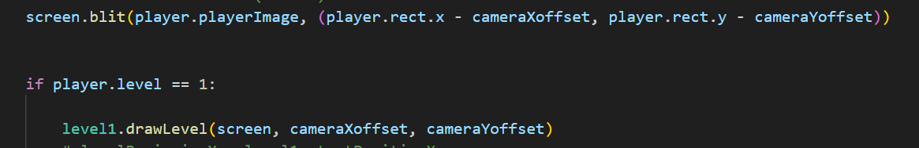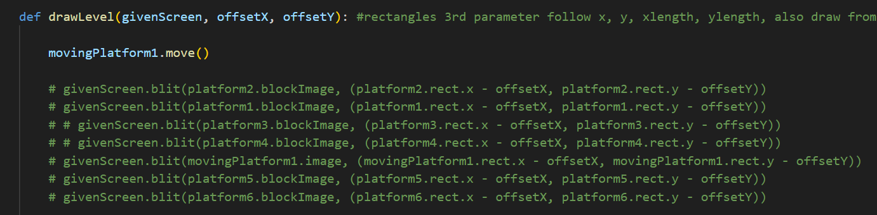

Drawing revamp>

While working on this solution, I noticed that the code for drawing objects that are in the level design onto the screen is very inefficient because if I was to make a large map design for the level, I would have to copy tens of lines of code to just draw them, I refined this by running a loop that goes through the group that consist of all platforms on the level, and drawing each iteration through the group.

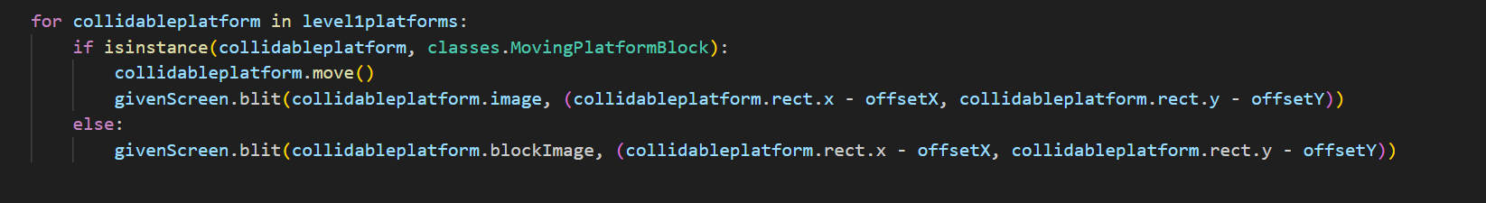

An alternative method I found was to use the method draw() directly on the group of objects, however this caused some issues that I wasn’t able to figure out what it meant by at the time, I also chose not to use this method because in the case that I would need to make changes to how certain objects are drawn, it would be harder to do so whereas with the for loop way I can make this adjustment much easier by just including it as an extra conditional in the for loop.



Menu screen bug

While implementing the menu screen, I noticed that the buttons for my menu screen have their texts displayed twice

(The image below uses a random place holder image, I was just testing if loading an image for the menu background works)

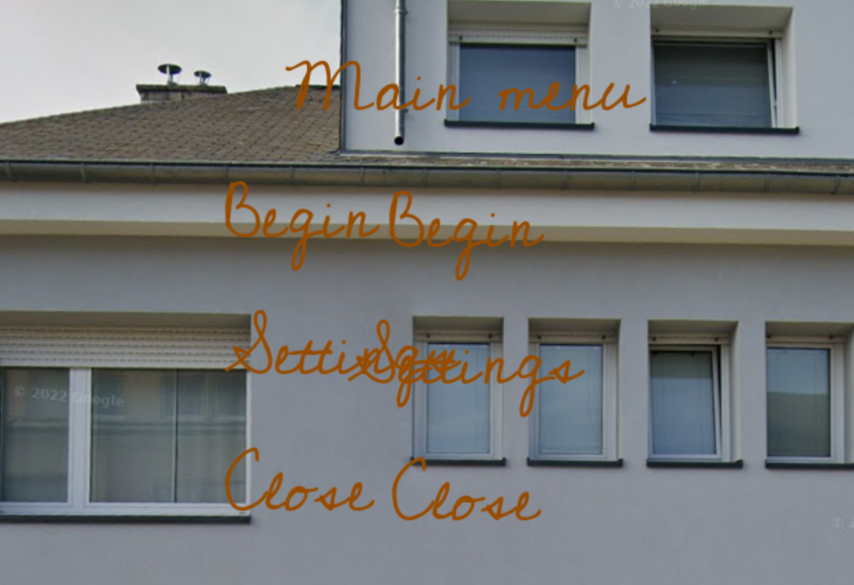

(still working on this one)

Background in game scroll

I wanted to add a background setting that changes on each level and also whenever you move, the background is an infinitely refreshing background the moves relative to your position to 1. Give the player an idea of the difficulty of the level 2. Give the game an ambience and some detail. The first issue I got with this was that whenever I moved, the background always scrolled to the left, even if I start moving to the left, which doesn’t make sense because if you have mountains on the background, you should expect them to move to the left out of view if you move to the right and vice versa if you move to the left.

Originally

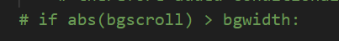

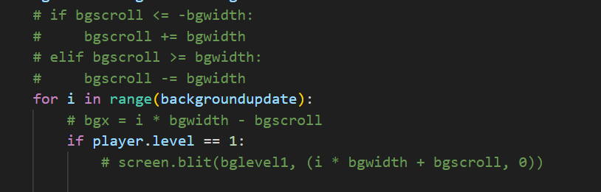

After fix:

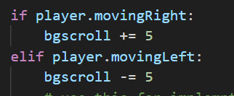

Replaced first image block of code

And



Replaces the second block of code

The thought process behind the first code was that if I did absolute value, regardless moving left and right, I could take that value, make a conditional then add or subtract the value depending on if you move left or right, however the issue with this is since if you move out of bounds (the out of bounds area is considered to be outside the original box / field of view when you first spawn in, by the game) the scroll will always be larger than the bgwidth, so the code always runs in the second block even if you stop moving. To fix this, by using the second block of code in the fixed section, by applying modulus, I can make the game know how much to move the background image by, without worrying about the width boundaries, as the modulus, since the bg scroll always has a factor of 5, if you mod it, the result will cycle through 0 mod 5, 1 mod 5, 2 mod 5, 3 mod

5, and 4 mod 5, so these 4 numbers will only be the results and we therefore have a boundary made (0, 1, 2, 3, 4)

Menu screen buttons error

While making the button class for my menu screen and interactivity options like opening settings, I encountered a simple bug / syntax error where while trying to create an instance of a button, I passed None as the image parameter for my buttons, I did this because I thought if I made an actual button image / outline for each button, i.e menu button, setting button, it would take up too much space of the game screen, so I thought if I just put down None, only the text will be written onto the screen and you can click the text to return to menu or go to settings. However when I define the class, I forgot that I had an attribute that uses the get_rect() method to get a rectangle out of the image parameter so I can perform mouse collision checks for later on.

## 

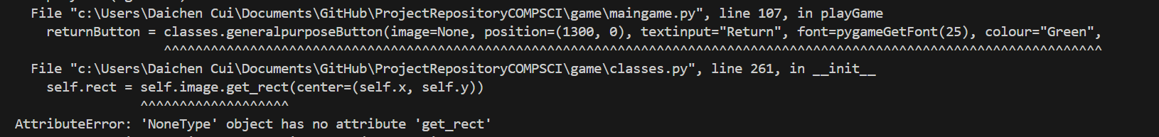

What I learnt from this is that whenever you initialise a class’s attributes, I need to keep in mind that when I am passing arguments for creating an instance of the class, the arguments must all be in some form that will be applicable to the class. I.e in this case, since I know I used the get_rect() method somewhere in the class, I need to keep in mind that the parameter that uses it, when I am passing a value, I need to provide a value that the block of code can work with, meaning None will not work because it isn’t a rectangle, so you cant get a rectangle hitbox out of it, whereas with an image you can.

## Stage 2

## Stage 3

# Testing Stage